**ASSIGNMENT 2 FRONT SHEET**

|  |  |  |  |
| --- | --- | --- | --- |
| **Qualification** | **BTEC Level 5 HND Diploma in Computing** | | |
| **Unit number and title** | 10: Website Design & Development | | |
| **Submission date** | 03 – May – 2022 | **Date Received 1st submission** |  |
| **Re-submission Date** |  | **Date Received 2nd submission** |  |
| **Student Name** | Trinh Duc Anh | **Student ID** | GCH210829 |
| **Class** | GCH1002 - 1633 | **Assessor name** | Lai Manh Dung |
| **Student declaration**  I certify that the assignment submission is entirely my own work and I fully understand the consequences of plagiarism. I understand that making a false declaration is a form of malpractice. | | | |
|  |  | **Student’s signature** |  |

**Grading grid**

|  |  |  |  |  |  |  |
| --- | --- | --- | --- | --- | --- | --- |
| P5 | P6 | P7 | M4 | M5 | D2 | D3 |
|  |  |  |  |  |  |  |

|  |  |  |
| --- | --- | --- |
| **❒ Summative Feedback: ❒ Resubmission Feedback:** | | |
| **Grade:** | **Assessor Signature:** | **Date:** |
| **Signature & Date:** | | |

Contents

I. Design plan 5

1. User requirements 5

User requirements 5

Client requirements 5

2. Review accessibility standards and guidelines 5

3. Use-case diagram 7

4. Wireframes 8

Home page 8

Contact page 9

Log in page 10

Sign up page 11

Admin homepage 12

Add/edit a product 13

Account management 14

Edit account’s info 15

Product details 16

5. Sitemap 17

II. Implementation 18

1. Source code samples 18

1.1 Home page 18

1.2 Contact page 21

1.3 Sign up page 23

1.4 Log in page 26

1.5 Admin page 28

1.6 Modify/Add product 30

1.7 Accounts 38

1.8 Add/edit staff account 43

1.9 Edit customer account 54

2. Comparison with the original design 60

III. Test plan 63

1. Introduction 63

2. Test case 63

3. Screenshot 65

3.1 Display products by brand and keyword 65

3.2 Contact form 67

3.3 Sign up 70

3.4 Log in 78

3.6 Delete product 82

3.7 Edit product 84

3.8 Add product 86

3.9 Account management 88

3.10 Edit account 90

3.11 Delete account 93

References 97

# I. Design plan

## 1. User requirements

An owner of a smartphone store has requested my company to make a website for their store so that they can expand their business to an e-commerce platform. The website is expected to be minimalist while maintaining important function of an online shop. Items should be spaced appropriately so that it does not feel cluttered. There are a number of requirements to be followed:

### User requirements

* A customer/user must be able to sign up for an account and log into the shop.
* Customers can add item(s) from the product page into their account’s cart.
* Customers can go to their cart and modify the quantity of the products they have added or delete them.
* Customers can check out and pay for the items in their cart
* Site’s visitors can submit a contact form to send feedback or to inquire for information.
* Visitors can search for products by inputting a product’s name or just a part of its name
* Visitors can filter what products are displayed by brands

### Client requirements

* The system must show the correct information for each product
* The correct products must be shown when the user performs a search function or chooses to display the products of a brand
* Links must direct the user to appropriate sites.
* The footer shows additional services that the store offers along with its social media accounts

## 2. Review accessibility standards and guidelines

To ensure that a website is accessible to its users, there are principles and guidelines that a website needs to follow in order to achieve that:

1. Perceivable
   1. Provide text alternatives for any non-text material so that it may be converted into formats that individuals require, such as big print, Braille, voice, symbols, or simpler language.
   2. Alternatives to time-based media should be provided.
   3. Create material that may be presented in a variety of ways (for example, a simpler layout) without sacrificing information or organization.
   4. Make it simpler for consumers to see and hear material by separating foreground and background elements.
2. Operable
   1. Make every function accessible through a keyboard.
   2. Allow users adequate time to read and interact with the material.
   3. Do not create content that is known or has a risk to trigger seizures.
   4. Provide methods to assist users in navigating, finding content, and determining their location.
3. Understandable
   1. Make your text more readable and comprehensible.
   2. Make Web pages appear and behave predictably.
   3. Assist users in avoiding and correcting errors.
4. Robust
   1. Compatibility with present and future user agents, including assistive technology, should be maximized.

(Centre For Accessibility Australia, 2022)

To create an e-commerce website that follows the mentioned principles and guidelines, the aesthetics and designs of the website may be affected in various ways.

* Items and links need to be properly spaced out so that the user can make sense of what is appearing on the screen.
* Items, texts, need to have color that contrasts their container, like the dark text on a bright color button and vice versa
* Fonts chosen need to be clear and readable by everyone, avoid niche fonts that are only aesthetic but not functional

## 3. Use-case diagram

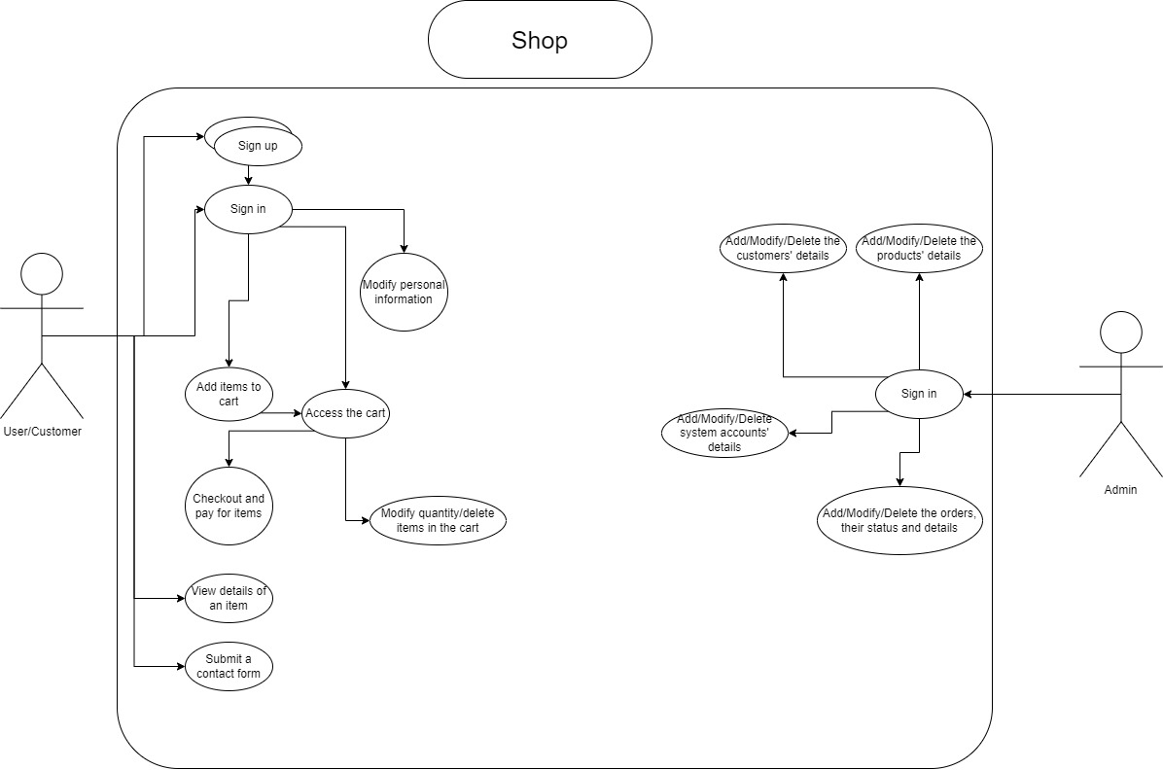

## 4. Wireframes

### Home page

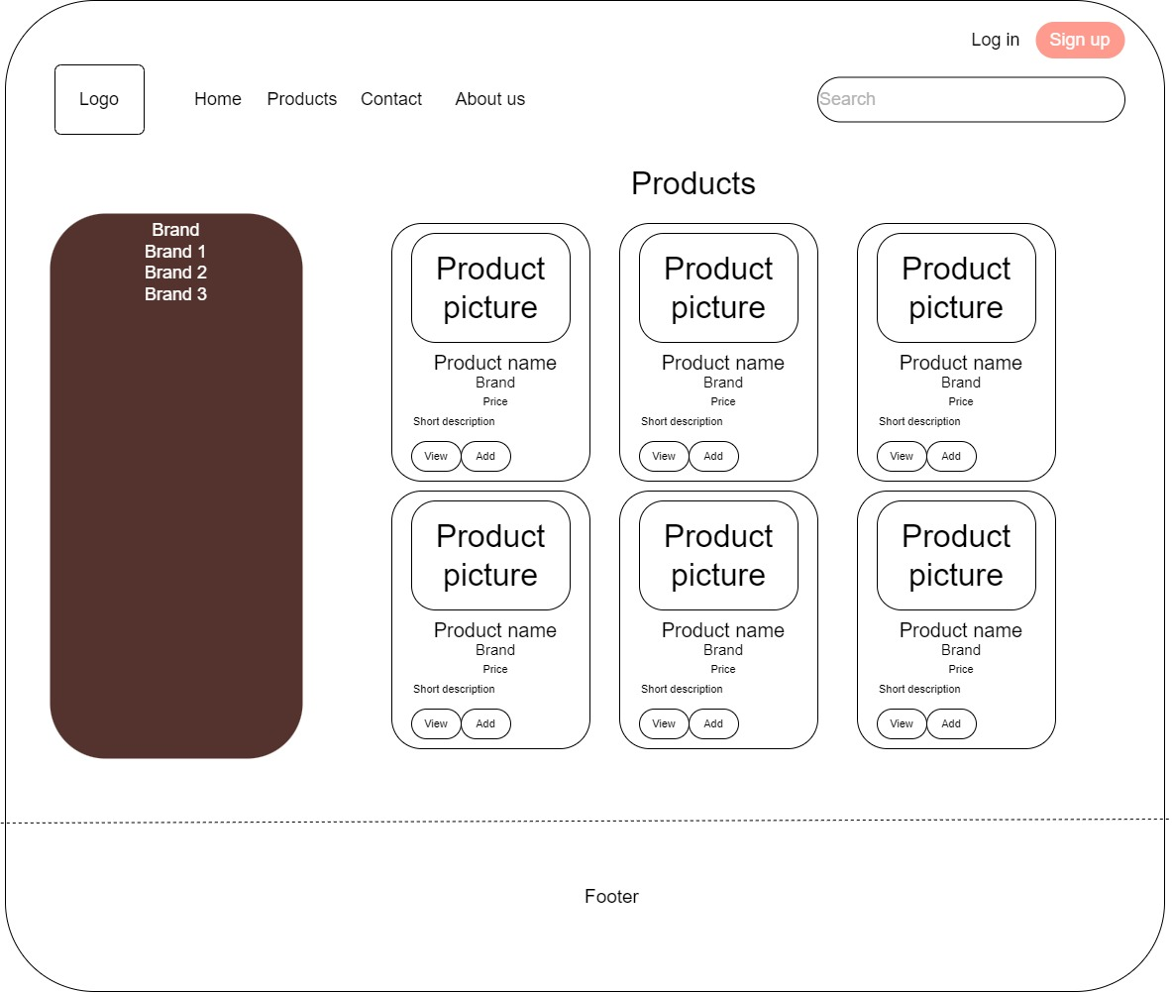

### Contact page

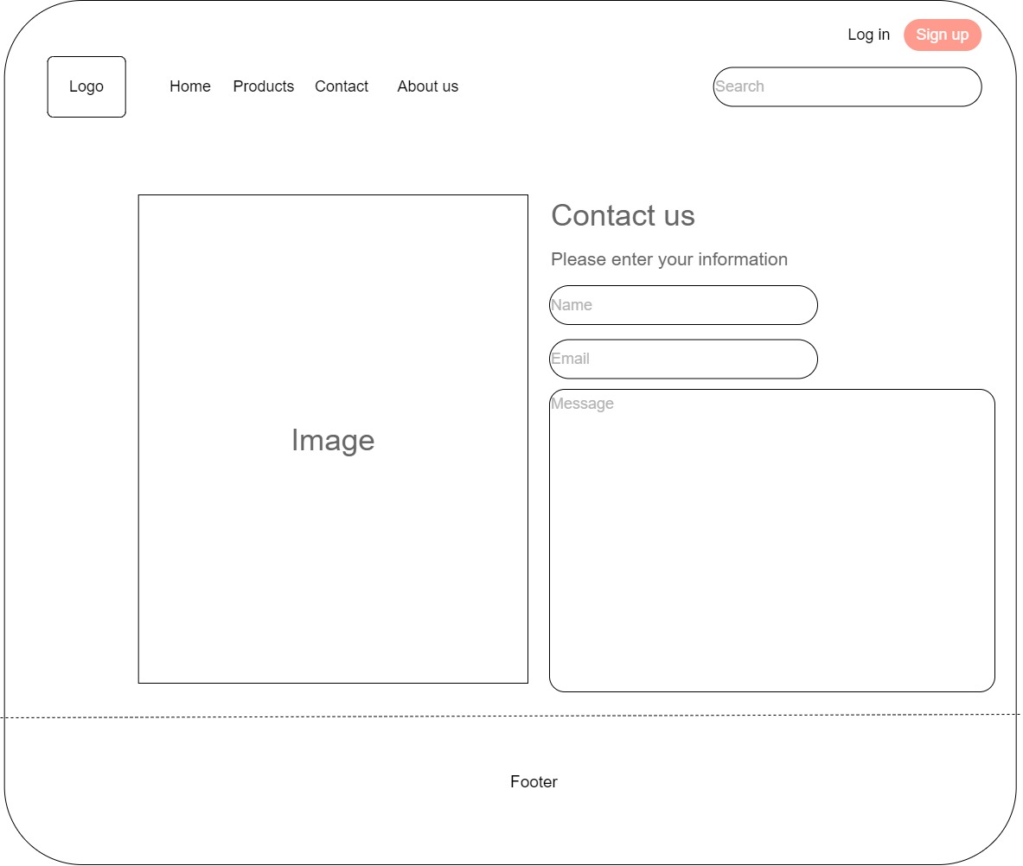

### Log in page

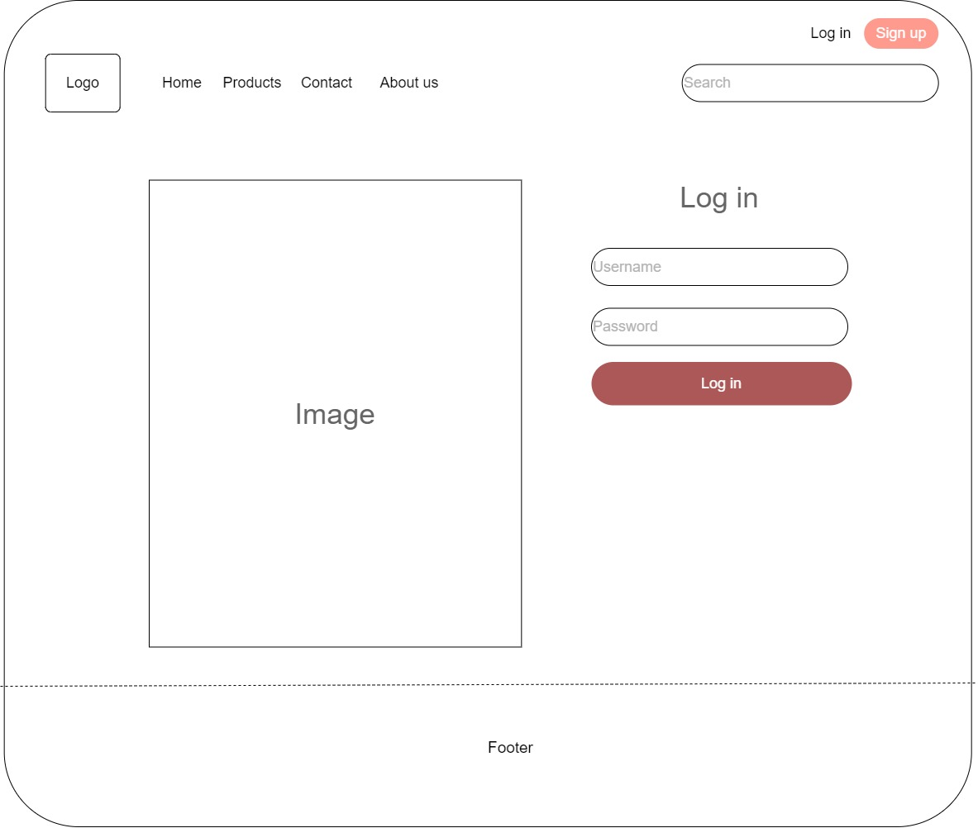

### Sign up page

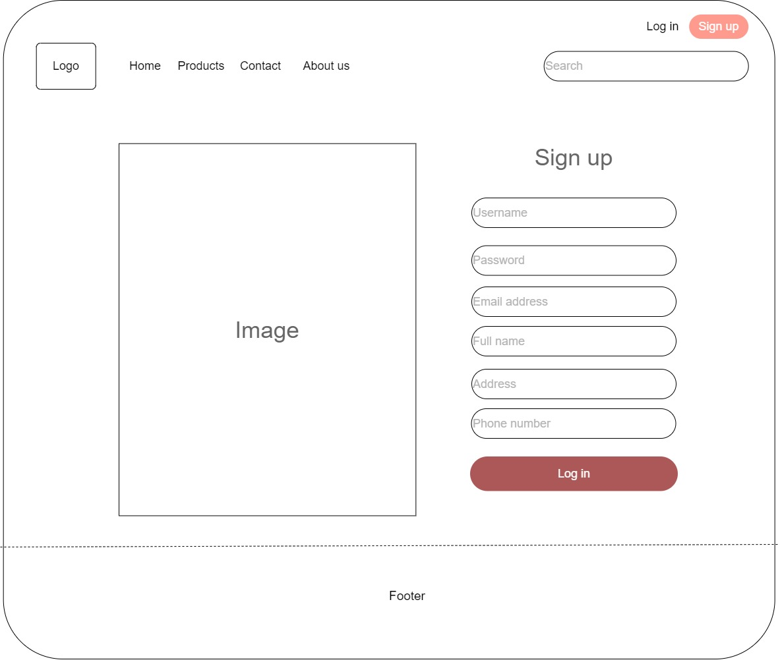

### Admin homepage

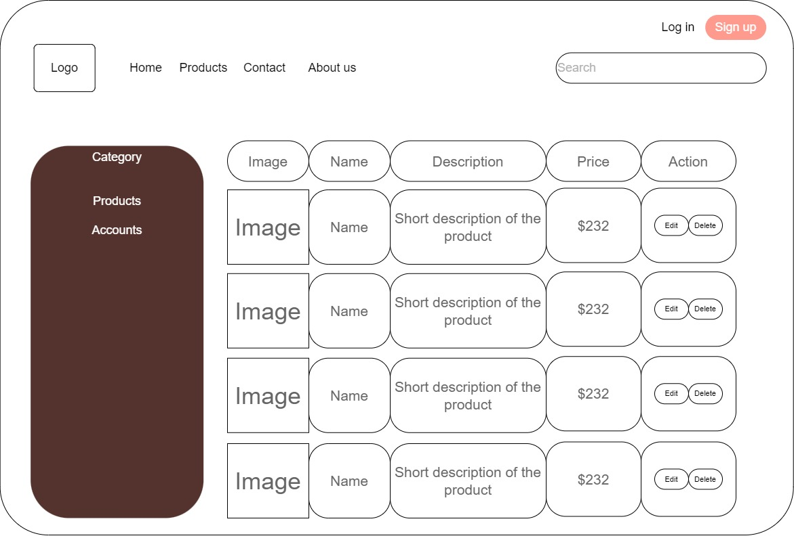

### Add/edit a product

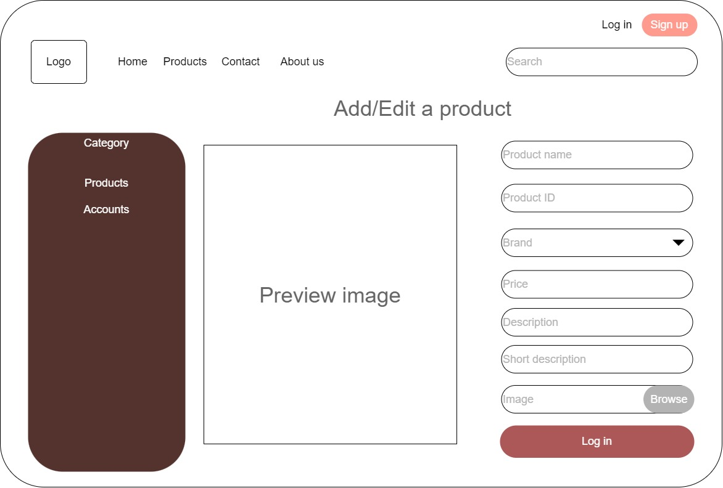

### Account management

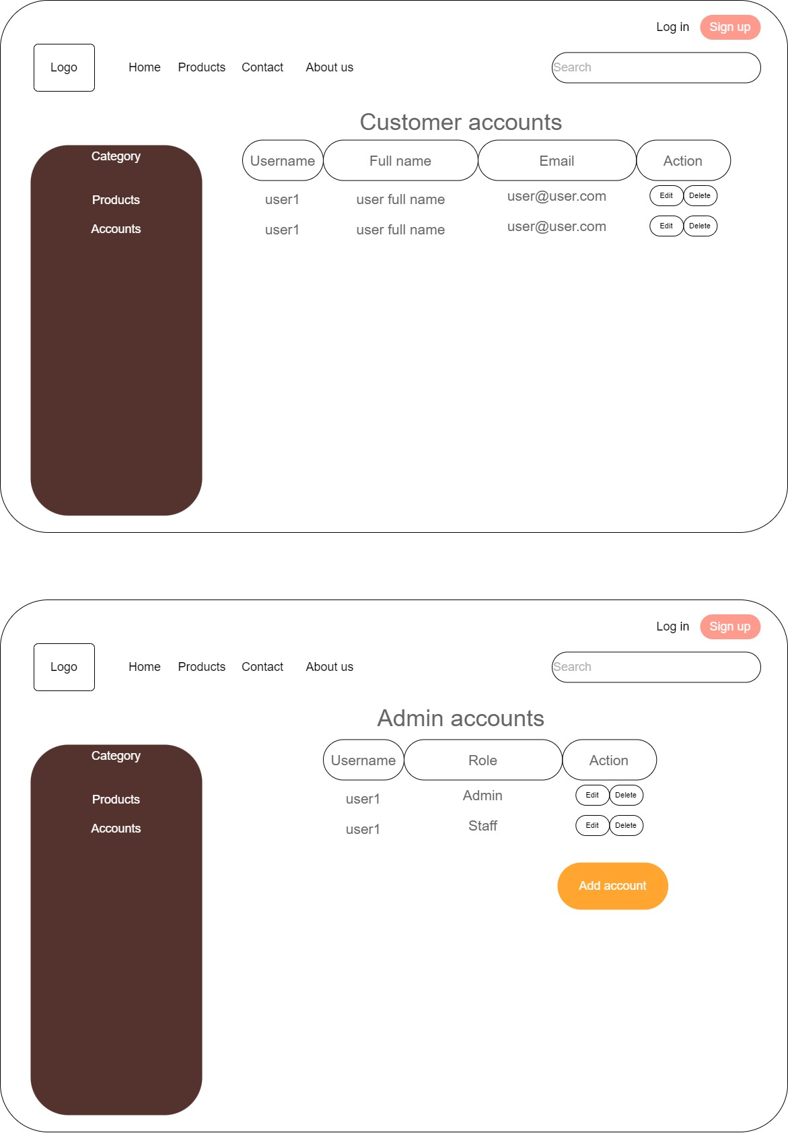

### Edit account’s info

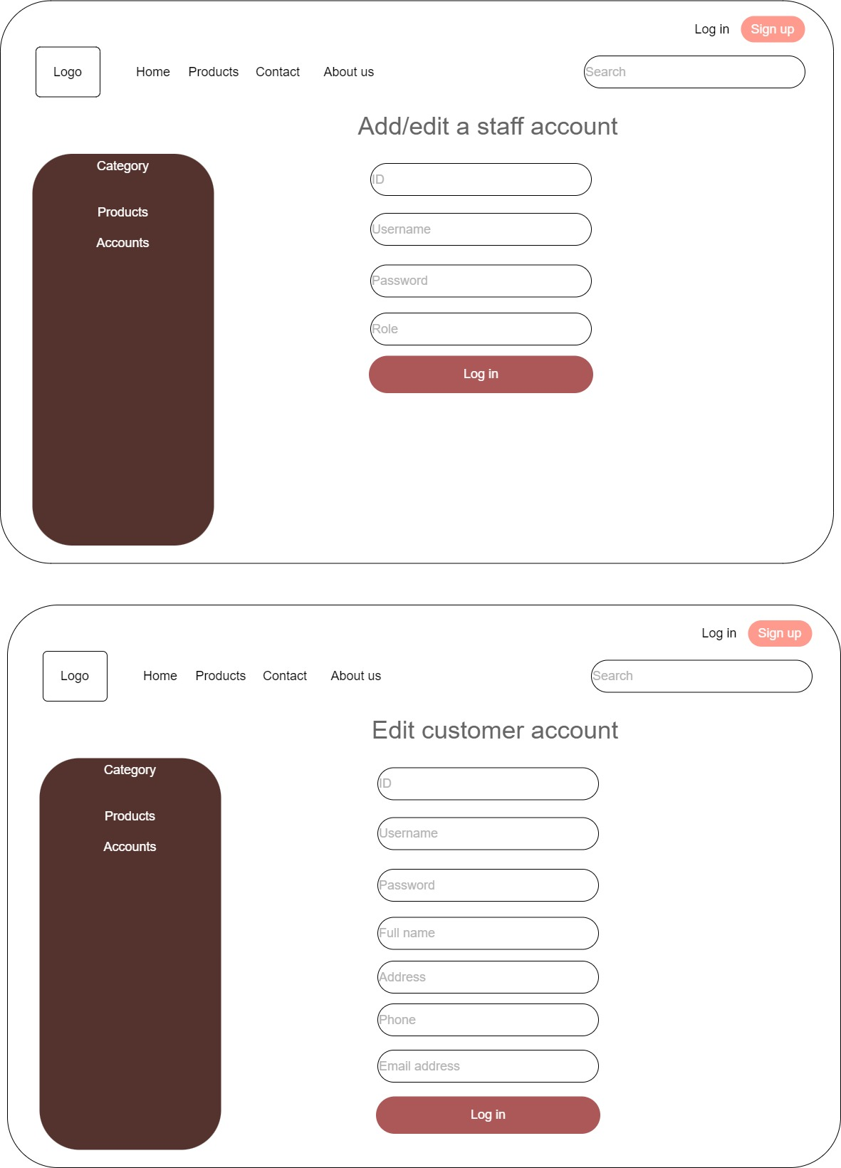

### Product details

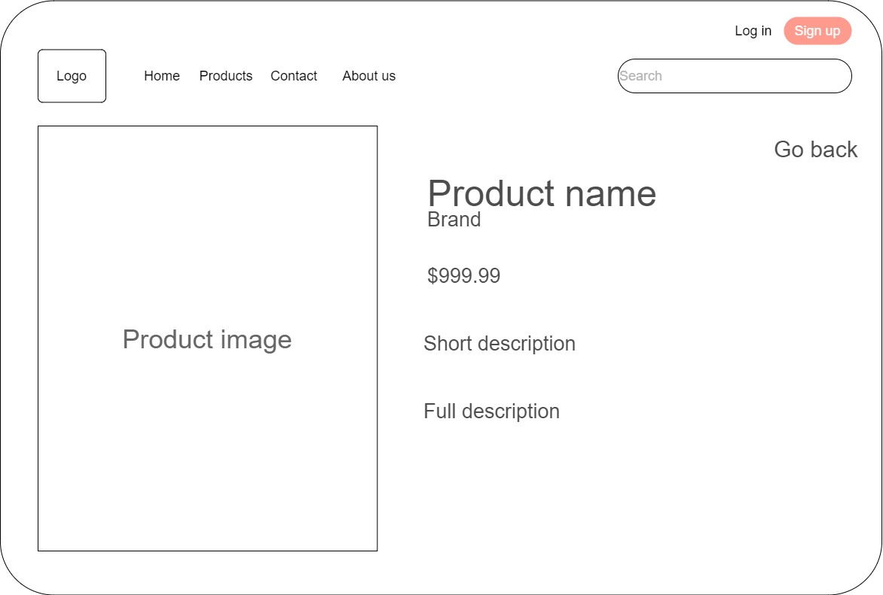

## 5. Sitemap

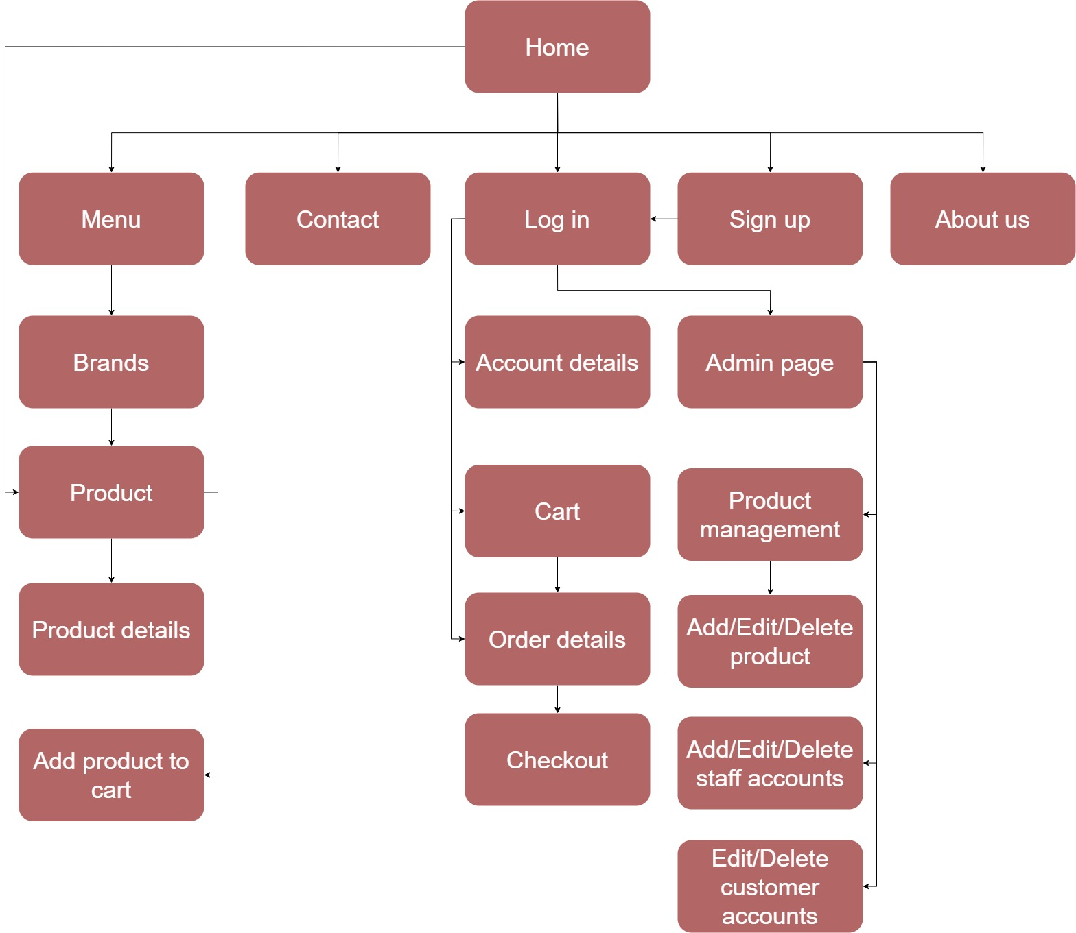

The Homepage contains multiple links, each leading to a different page. It also contains sections such as a menu, product list, and a search field for the user to search for some specific products. The menu contains multiple brands, when the user clicks on one, the products of that brand are displayed. In the products list. Each product is presented with its picture, brand, price, a short description and buttons to view details and add to the cart.

# II. Implementation

## 1. Source code samples

### 1.1 Home page

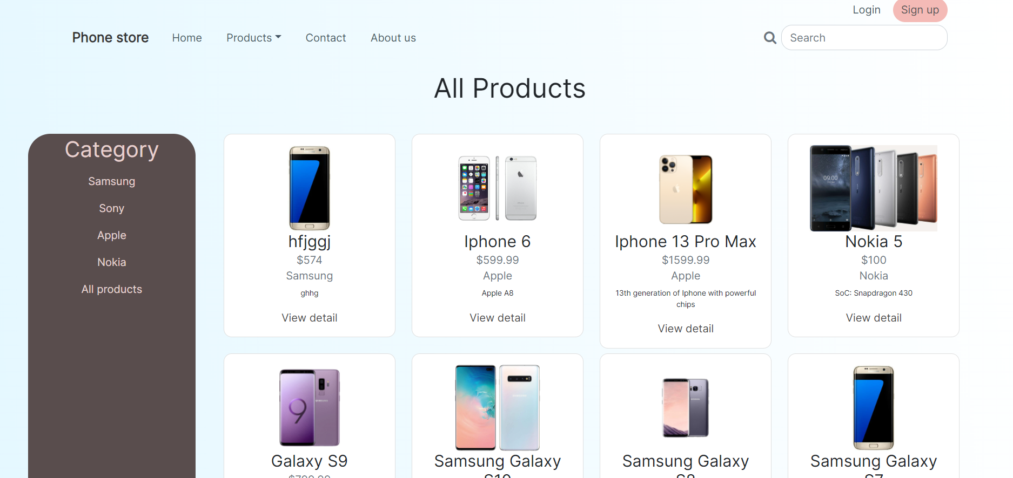

This is the homepage of the store. On this page, logging in is not required, the visitor can choose to filter devices by brand, search by name, log in or sign up as they wish.

<div class="col-xl-3 col-xxl-2" style="background: #594d4d;border-radius: 33px;color: rgb(231,208,206);">

<div></div>

<h2 style="text-align: center;margin-top: 2%;">Category</h2>

<ul class="list-group" style="background: rgba(255,255,255,0);border-style: none;color: rgb(231, 208, 206);text-align: center;">

<?php foreach ($categories as $category) : ?>

<a style="text-decoration: none" href="eshop.php?category=<?php echo $category[0]; ?>"><li class="list-group-item" style="background: rgba(255,255,255,0);color: rgb(230,213,211);border-style: none;"><span><?php echo $category[1]; ?></span></li></a>

<?php endforeach; ?>

<a style="text-decoration: none" href="eshop.php?category=<?php echo"all";?>"><li class="list-group-item" style="background: rgba(255,255,255,0);color: rgb(230,213,211);border-style: none;"><span>All products</span></li></a>

</ul>

</div>

This is the piece of code used to display the brands that are in the system. Using the function *foreach* in php*,* every brand of devices that exists in the system will be displayed without missing any.

<div class="col-lg-9 col-xl-8 col-xxl-9" style="margin-right: 0%;margin-left: 2%;border-style: none;border-radius: 56px;">

<div></div>

<div class="row">

<?php foreach ($productsfull as $product) : ?>

<div class="col-xxl-3 col-xl-3 justify-content-xxl-center align-items-xxl-center">

<div class="card" style="border-radius: 12px; margin-bottom:3%">

<div class="card-body"><img src="<?php echo $product[2]; ?>" height="128">

<h4 class="card-title"><?php echo $product[1]; ?></h4>

<h6 class="card-subtitle mb-2 text-muted">$<?php echo $product[3]; ?></h6>

<h6 class="text-muted card-subtitle mb-2"><?php echo $product[8]; ?></h6>

<p class="card-text" style="font-size: 11px;"><?php echo $product[6]; ?></p><a class="card-link" href="product.php?id=<?php echo $product[0]; ?>" style="text-decoration: none;border-style: none;border-color: rgb(68,68,68);color: rgb(72,72,72);">View detail</a>

</div>

</div>

</div>

<?php endforeach; ?>

</div>

</div>

This is the code used to display the products of the chosen brand onto the product list. If no brand is chosen, all products in the system will be displayed.

### 1.2 Contact page

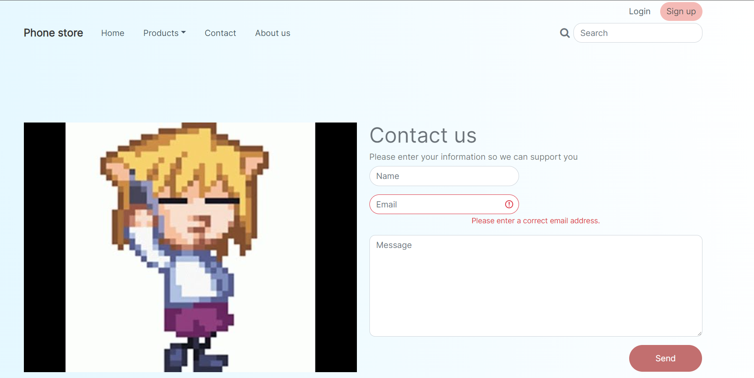

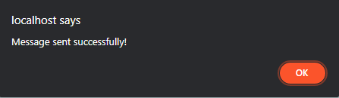

After the user inputs their information and message, the information entered will be transferred to the database.

<div class="col-md-6 text-center" style="color: rgba(51,58,65,0.71);">

<h1 style="text-align: left;">Contact us</h1>

<h6 style="text-align: left;">Please enter your information so we can support you</h6>

<form action="contact.php" method="post" style="width: 100%;">

<div class="mb-3"><input class="form-control" type="text" id="name" name="name" placeholder="Name" style="width: 45%;border-radius: 32px;"></div>

<div class="mb-3"><input class="form-control is-invalid" type="email" id="email" name="email" placeholder="Email" style="width: 45%;border-radius: 40px;"><small class="form-text text-danger">Please enter a correct email address.</small></div>

<div class="mb-3"><textarea class="form-control" name="message" id="message" placeholder="Message" rows="14" style="border-radius: 11px;height: 194px;"></textarea></div>

<div class="mb-3"><button class="btn btn-primary" id="submit" name="submit" type="submit" style="background: #c26f6f;width: 22%;height: 51px;border-radius: 43px;border-style: none;margin-left: 78%;">Send</button></div>

</form>

</div>

This is the code used to display the contact form, the form then uses the method POST to send the query to the server and saves the information there

### 1.3 Sign up page

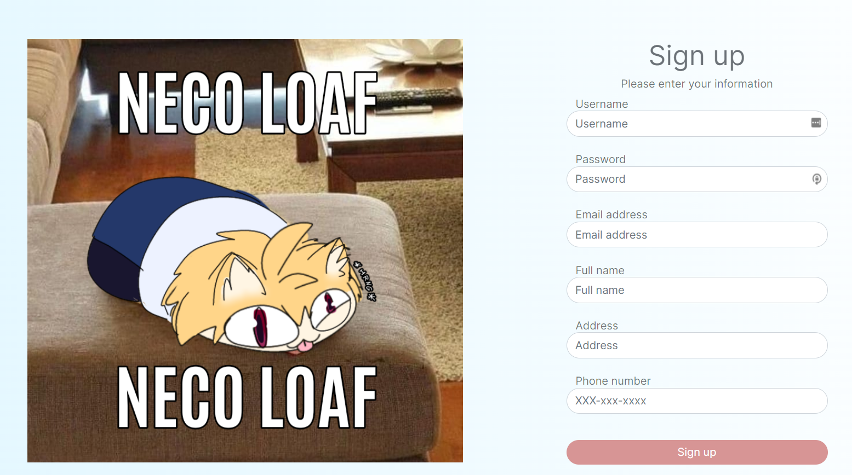

After the user input the information of the account that they want to create, the server checks if there is any username and email duplication before creating a new account in the system. If there’s no duplication, the process succeeds.

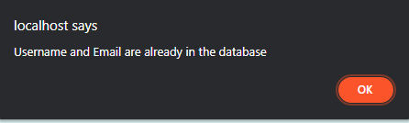

<div class="col-md-6 text-center" style="color: rgba(51,58,65,0.71);">

<h1>Sign up</h1>

<h6>Please enter your information</h6>

<form action = "signup.php" method = "POST"class="d-xl-flex flex-column justify-content-xl-center align-items-xl-start" style="width: 60%;margin-right: auto;margin-left: auto;">

<label class="form-label" for="username" style="margin-bottom: -2px;margin-left: 3.5%;">Username</label>

<input class="form-control" type="text" id="username" name="username" placeholder="Username" style="border-radius: 25px;">

<label class="form-label" for="password" style="margin-bottom: -2px;margin-top: 21px;margin-left: 3.5%;">Password</label>

<input class="form-control" type="password" id="password" placeholder="Password" name="password" style="border-radius: 25px;">

<label class="form-label" for="email" style="margin-bottom: -2px;margin-top: 21px;margin-left: 3.5%;">Email address</label>

<input class="form-control" type="text" id="email" name="email" placeholder="Email address" style="border-radius: 25px;">

<label class="form-label" for="fullname" style="margin-bottom: -2px;margin-top: 21px;margin-left: 3.5%;">Full name</label>

<input class="form-control" type="text" id="fullname" name="fullname" placeholder="Full name" style="border-radius: 25px;">

<label class="form-label" for="address" style="margin-bottom: -2px;margin-top: 21px;margin-left: 3.5%;">Address</label>

<input class="form-control" type="text" id="address" name="address" placeholder="Address" style="border-radius: 25px;">

<label class="form-label" for="phone" style="margin-bottom: -2px;margin-top: 21px;margin-left: 3.5%;">Phone number</label>

<input class="form-control" id="phone" type="tel" name="phone" placeholder="XXX-xxx-xxxx" style="border-radius: 25px;">

<button class="btn btn-primary" name="submit" type="submit" style="margin-left: auto;margin-right: auto;width: 100%;margin-top: 10%;border-radius: 56px;border-style: none;background: rgb(215,149,149);">Sign up</button>

</form>

</div>

This is the code to display the form that will take the input from the user and pass those to the server.

### 1.4 Log in page

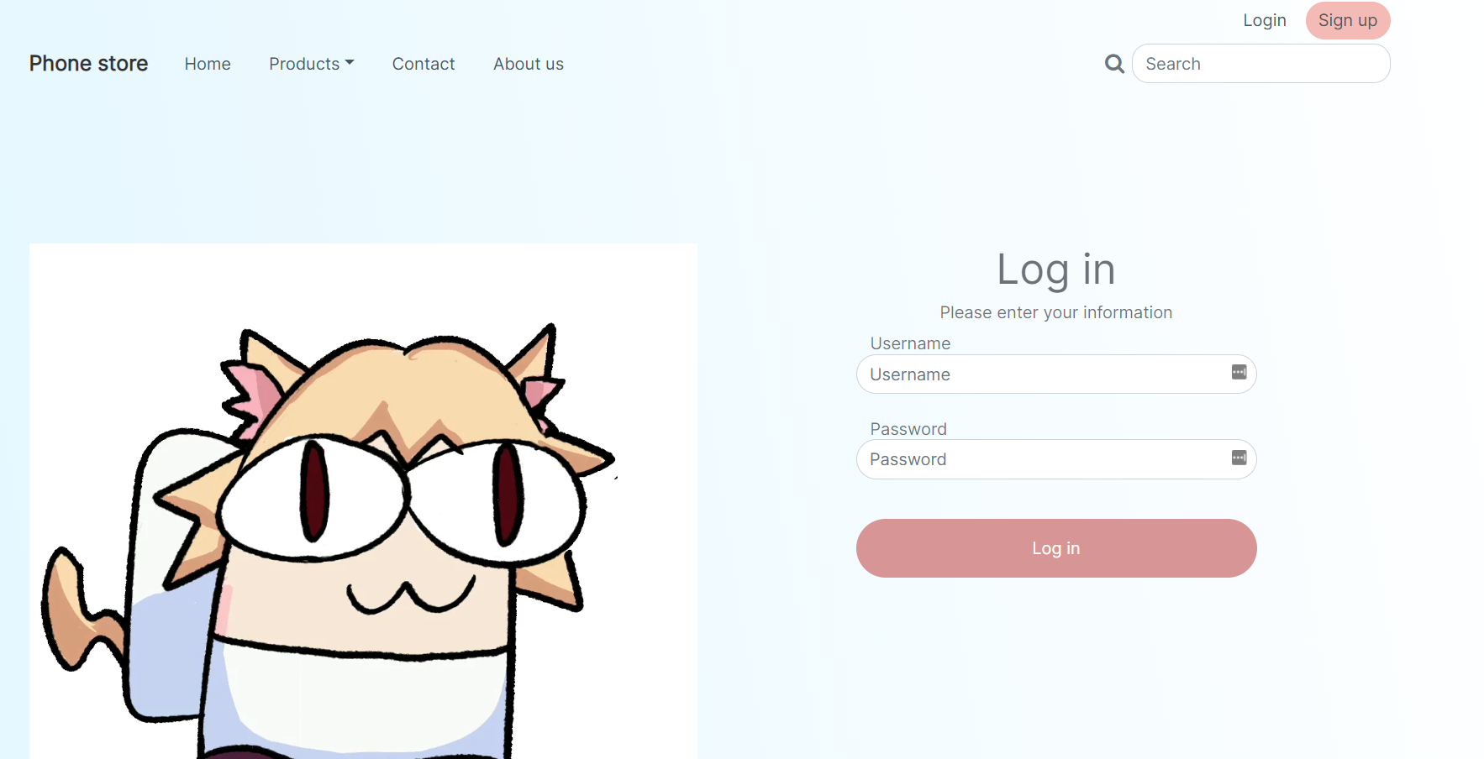

This is the log in page for the admin. When the correct credentials are input, it redirects the user to the admin page where they can manage products and accounts.

<div class="col-md-6 text-center" style="color: rgba(51,58,65,0.71);">

<h1>Log in</h1>

<h6>Please enter your information</h6>

<form action="signin.php" method="post" class="d-xl-flex flex-column justify-content-xl-center align-items-xl-start" style="width: 60%;margin-right: auto;margin-left: auto;">

<label class="form-label" for="Username" style="margin-bottom: -2px;margin-left: 3.5%;">Username</label>

<input class="form-control" type="text" id="Username" name="Username" placeholder="Username" style="border-radius: 25px;">

<label class="form-label" for="password" style="margin-bottom: -2px;margin-top: 21px;margin-left: 3.5%;">Password</label>

<input class="form-control" type="password" placeholder="Password" name="password" id="password" style="border-radius: 25px;">

<button class="btn btn-primary" type="submit" style="margin-left: auto;margin-right: auto;width: 100%;margin-top: 10%;border-radius: 56px;border-style: none;background: rgb(215,149,149);height: 56px;">Log in</button>

</form>

</div>

### 1.5 Admin page

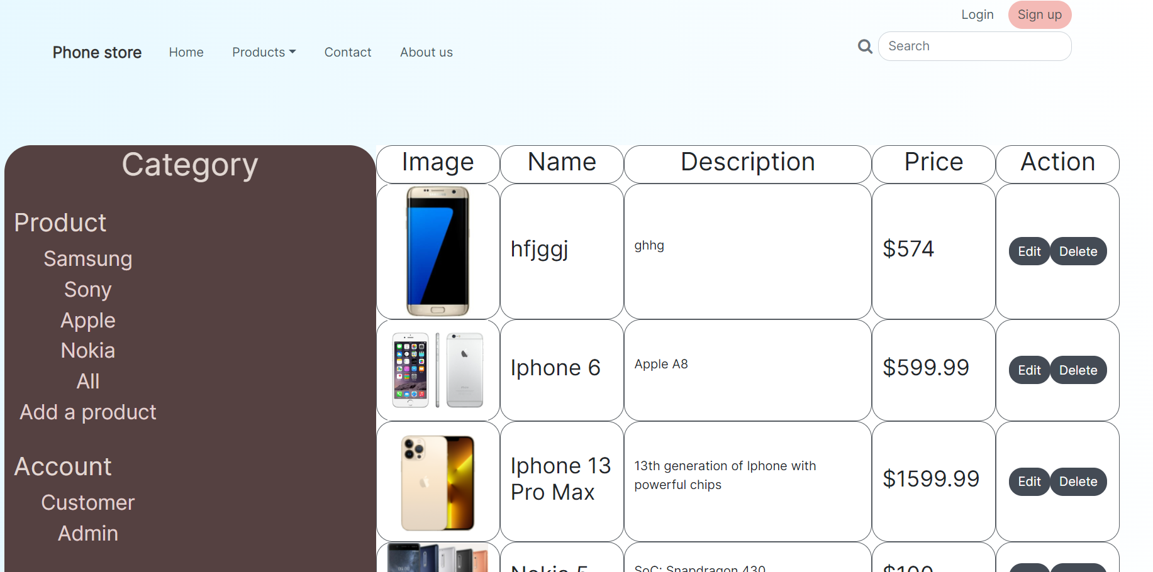

In this page, the user will be able to manage the products on the system.

<?php foreach ($productsfull as $product) { ?>

<div class="row">

<div class="col-xxl-2 d-xxl-flex align-items-xxl-center" style="border-radius: 21px;border: 1px solid rgb(87,93,99) ;">

<img class="d-xxl-flex justify-content-xxl-center" style="margin: auto;margin-right: auto;" src="<?php echo $product[2]; ?>" width="128px"></div>

<div class="col-xxl-2 d-xxl-flex align-items-xxl-center" style="border-radius: 21px;border: 1px solid rgb(87,93,99) ;">

<h3><?php echo $product[1]; ?></h3>

</div>

<div class="col-xxl-4 d-xxl-flex align-items-xxl-center" style="border-radius: 21px;border: 1px solid rgb(87,93,99) ;">

<p><br><?php echo $product[6]; ?><br><br></p>

</div>

<div class="col-xxl-2 d-xxl-flex align-items-xxl-center" style="border-radius: 21px;border: 1px solid rgb(87,93,99) ;">

<h3>$<?php echo $product[3]; ?></h3>

</div>

<div class="col-xxl-2 d-xxl-flex justify-content-xxl-center align-items-xxl-center" style="border-radius: 21px;border: 1px solid rgb(87,93,99) ;">

<div class="btn-group d-xxl-flex justify-content-xxl-center" role="group">

<a role="button" href="editproduct.php?editID=<?php echo $product[0] ?>" class="btn btn-primary" type="button" style="background: rgb(68,75,85);border-style: none;border-radius: 17px;">Edit</a>

<a role="button" href="admin.php?delete=<?php echo $product[0] ?>" name="delete" class="btn btn-primary" type="button" style="background: rgb(68,75,85);border-radius: 17px;border-style: none; text-decoration: none;">Delete</a>

</div>

</div>

</div>

<?php } ?>

Similar to the product list on the homepage, php function *foreach* is used to display products onto the screen.

### 1.6 Modify/Add product

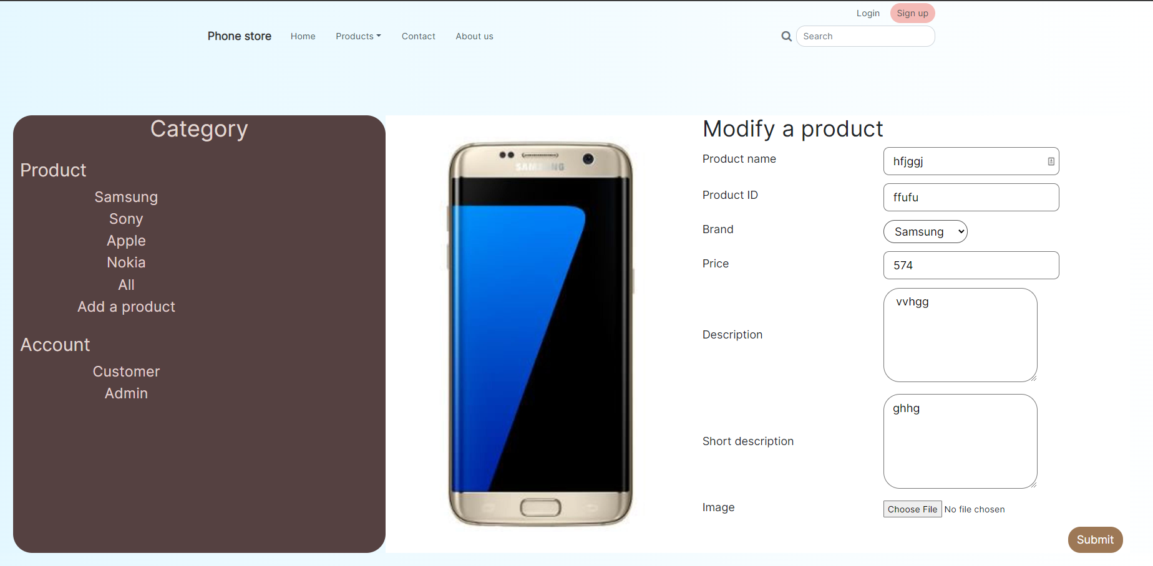

<div class="row">

<div class="col-xxl-5 d-xxl-flex justify-content-xxl-center align-items-xxl-center"><img src="<?php echo $rows[0][2] ?>" id="file-ip-1-preview" width="100%"></div>

<div class="col-xxl-7">

<form action="editproduct.php" method="post" enctype="multipart/form-data">

<div class="row">

<div class="col">

<div class="row">

<div class="col">

<h1>Modify a product</h1>

<div class="row" style="margin-bottom: 2%;">

<div class="col-xxl-5 d-xxl-flex align-items-xxl-center">

<div class="row">

<div class="col">

<h5>Product name</h5>

</div>

</div>

</div>

<div class="col-xxl-6">

<div class="row">

<div class="col"><input class="form-control-lg" value="<?php echo $rows[0][1] ?>" type="text" name="ProductName" placeholder="Product name" style="border-radius: 10px;border-style: solid;"></div>

</div>

</div>

</div>

<!--Input for product ID-->

<div class="row" style="margin-bottom: 2%;">

<div class="col-xxl-5 d-xxl-flex align-items-xxl-center">

<div class="row">

<div class="col">

<h5>Product ID</h5>

</div>

</div>

</div>

<div class="col-xxl-6">

<div class="row">

<div class="col"><input class="form-control-lg" value="<?php echo $rows[0][0] ?>" type="text" id="ProductID" name="ProductID" placeholder="Product ID" style="border-radius: 10px;border-style: solid;"></div>

</div>

</div>

</div>

<div class="row" style="margin-bottom: 2%;">

<div class="col-xxl-5 d-xxl-flex align-items-xxl-center">

<div class="row">

<div class="col">

<h5>Brand</h5>

</div>

</div>

</div>

<div class="col-xxl-6">

<div class="row">

<div class="col"><select name="category" id="category" class="form-select-lg" style="border-radius: 20px;border-style: solid;border-color: rgb(82,82,82);">

<optgroup label="Choose a brand">

<!--Default option-->

<option value="<?php echo $rows[0][4] ?>"><?php echo $categoryEdit[0][8] ?></option>

<?php foreach ($categories as $category) { ?>

<option value="<?php echo $category[0]; ?>"><?php echo $category[1]; ?></option>

<?php } ?>

</optgroup>

</select></div>

</div>

</div>

</div>

<div class="row" style="margin-bottom: 2%;">

<div class="col-xxl-5 d-xxl-flex align-items-xxl-center">

<div class="row">

<div class="col">

<h5>Price</h5>

</div>

</div>

</div>

<div class="col-xxl-6">

<div class="row">

<div class="col"><input class="form-control-lg" value = "<?php echo $rows[0][3] ?>" type="text" name="Price" placeholder="Price" style="border-radius: 10px;border-style: solid;"></div>

</div>

</div>

</div>

<div class="row" style="margin-bottom: 2%;">

<div class="col-xxl-5 d-xxl-flex align-items-xxl-center">

<div class="row">

<div class="col">

<h5>Description</h5>

</div>

</div>

</div>

<div class="col-xxl-6">

<div class="row">

<div class="col"><textarea class="form-control-lg" name="FDescription" placeholder="SoC: S*** 888" rows="5" style="border-radius: 29px;"> <?php echo $rows[0][5] ?></textarea></div>

</div>

</div>

</div>

<div class="row" style="margin-bottom: 2%;">

<div class="col-xxl-5 d-xxl-flex align-items-xxl-center">

<div class="row">

<div class="col">

<h5>Short description</h5>

</div>

</div>

</div>

<div class="col-xxl-6">

<div class="row">

<div class="col"><textarea class="form-control-lg" name="BDescription" placeholder="SoC: S*** 888" rows="5" style="border-radius: 29px;"><?php echo $rows[0][6] ?></textarea></div>

</div>

</div>

</div>

<div class="row" style="margin-bottom: 2%;">

<div class="col-xxl-5 d-xxl-flex align-items-xxl-center">

<div class="row">

<div class="col">

<h5>Image</h5>

</div>

</div>

</div>

<div class="col-xxl-6">

<div class="row">

<div class="col">

<input type="file" value="<?php echo $rows[0][2] ?>"name="imageupload" id="imageupload" onchange="showPreview(event);" onload="showPreview(event)">

</div>

</div>

</div>

</div>

<div class="row">

<div class="col d-xxl-flex justify-content-xxl-end">

<button class="btn btn-primary btn-lg" name="submit" type="submit" style="background: rgb(157,120,86);border-style: none;border-radius: 22px;">Submit</button></div>

</div>

</div>

</div>

</div>

</div>

</form>

</div>

</div>

</div>

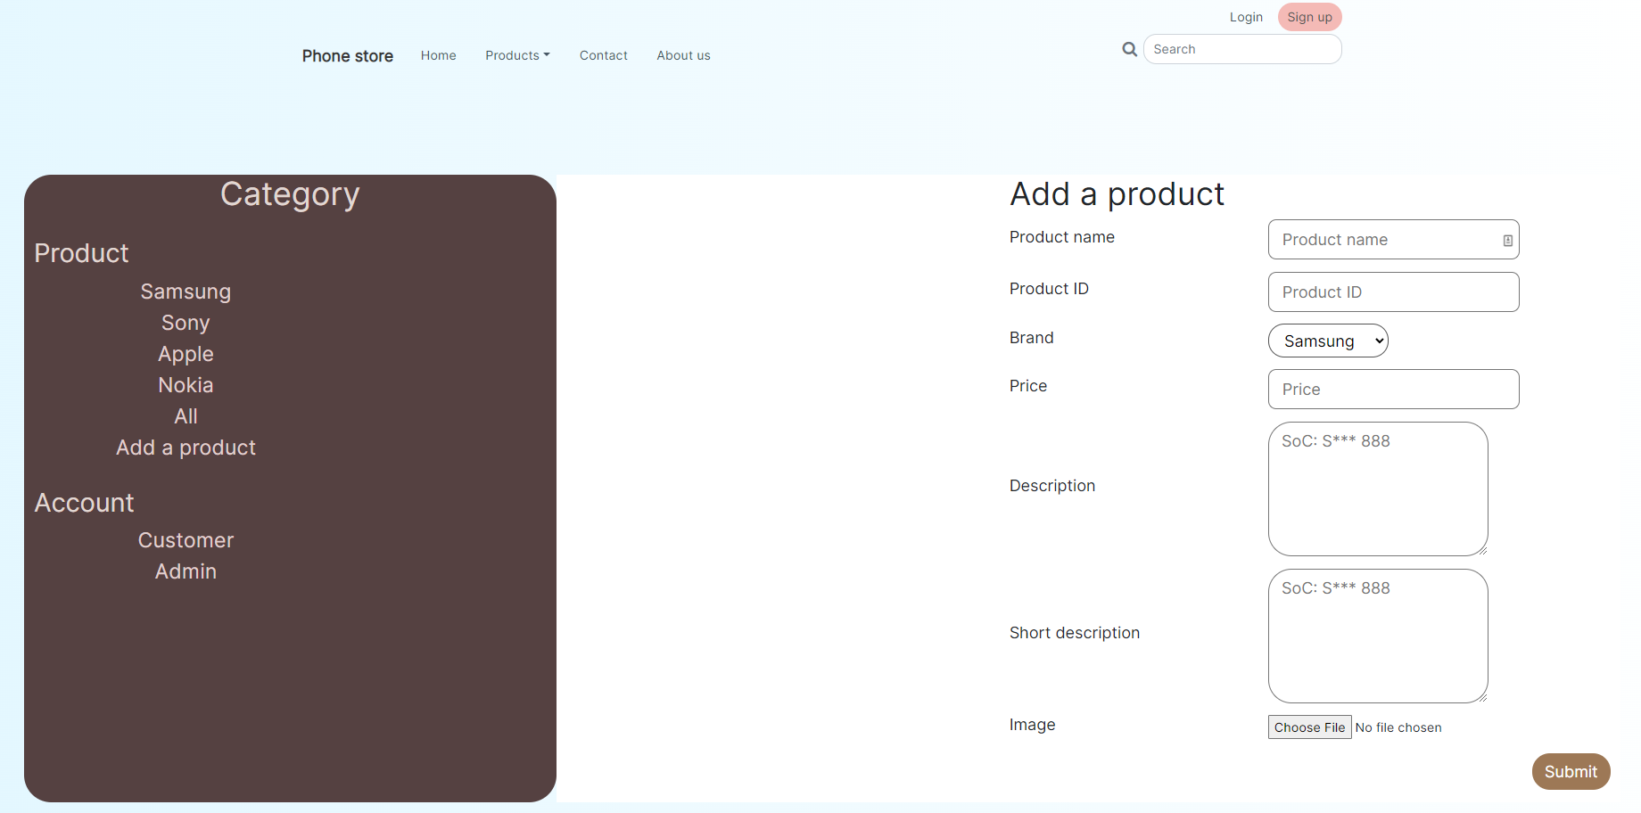

Add and modify has similar design and code. The difference is that on the modify page the sql code used is UPDATE while it is INSERT on the add one.

### 1.7 Accounts

These pages display the information of accounts on the system along with actions that can be made on those accounts

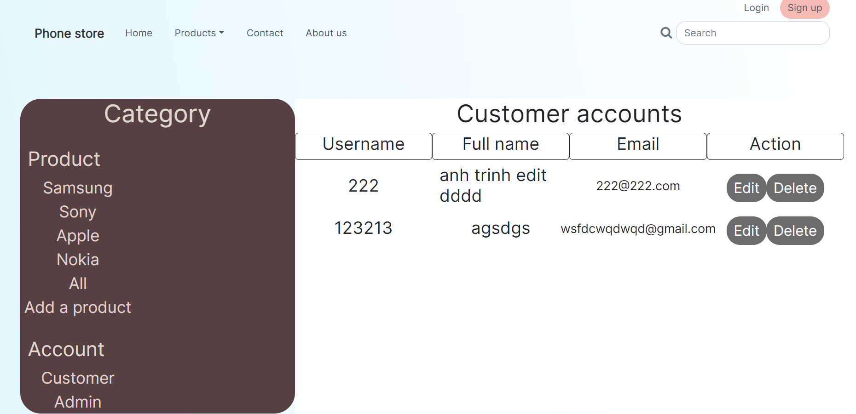

<?php foreach($customers as $customer) { ?>

<div class="row" style="margin-bottom: 1%;">

<div class="col-xxl-3 d-xxl-flex justify-content-xxl-center align-items-xxl-center">

<h3><?php echo $customer[5]; ?></h3>

</div>

<div class="col-xxl-3 d-xxl-flex justify-content-xxl-center align-items-xxl-center">

<h3><?php echo $customer[1]; ?></h3>

</div>

<div class="col-xxl-3 d-xxl-flex justify-content-xxl-center align-items-xxl-center">

<h5><?php echo $customer[4]; ?></h5>

</div>

<div class="col-xxl-3 d-xxl-flex justify-content-xxl-center align-items-xxl-center">

<div class="btn-group" role="group">

<a role="button" href="editcustomer.php?editId=<?php echo$customer[0]?>" class="btn btn-primary" type="button" style="background: rgb(108,108,108);border-style: none;border-radius: 22px;font-size: 23px;">Edit</a>

<a role="button" href="admin-CustomerAccs.php?delete=<?php echo$customer[0]?>" class="btn btn-primary" type="button" style="background: rgb(108,108,108);border-style: none;border-radius: 22px;font-size: 23px;">Delete</a>

</div>

</div>

</div>

<?php } ?>

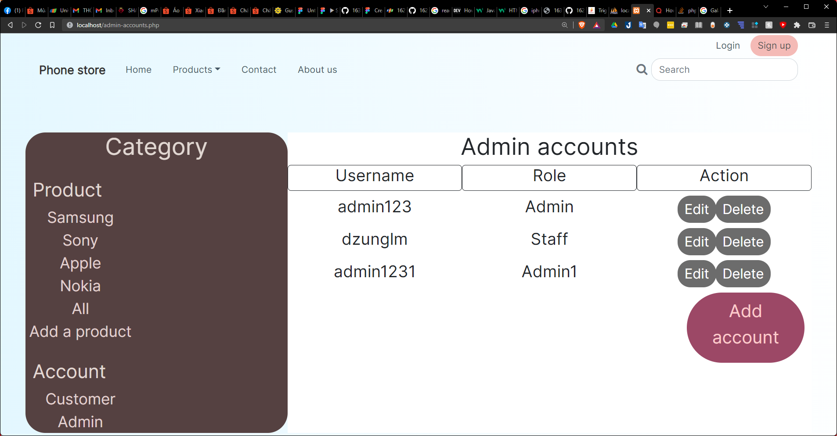

<div class="row">

<div class="col d-xxl-flex justify-content-xxl-center align-items-xxl-center">

<h1>Admin accounts</h1>

</div>

</div>

<div class="row" style="margin-bottom: 1%;">

<div class="col-xxl-4 d-xxl-flex justify-content-xxl-center align-items-xxl-center EditColumnBorder">

<h3>Username</h3>

</div>

<div class="col-xxl-4 d-xxl-flex justify-content-xxl-center align-items-xxl-center EditColumnBorder">

<h3>Role</h3>

</div>

<div class="col-xxl-4 d-xxl-flex justify-content-xxl-center align-items-xxl-center EditColumnBorder">

<h3>Action</h3>

</div>

</div>

<?php foreach ($accounts as $account) { ?>

<div class="row" style="margin-bottom: 1%;">

<div class="col-xxl-4 d-xxl-flex justify-content-xxl-center align-items-xxl-center">

<h3><?php echo $account[1]; ?></h3>

</div>

<div class="col-xxl-4 d-xxl-flex justify-content-xxl-center align-items-xxl-center">

<h3><?php echo $account[3]; ?></h3>

</div>

<div class="col-xxl-4 d-xxl-flex justify-content-xxl-center align-items-xxl-center">

<div class="btn-group" role="group">

<a role="button" href="editStaffAcc.php?editID=<?php echo $account[0] ?>" class="btn btn-primary" type="button" style="background: rgb(108,108,108);border-style: none;border-radius: 22px;font-size: 23px;">Edit</a>

<a role="button" href="admin-accounts.php?delete=<?php echo $account[0] ?>"class="btn btn-primary" type="button" style="background: rgb(108,108,108);border-style: none;border-radius: 22px;font-size: 23px;">Delete</a></div>

</div>

</div>

<?php } ?>

<div class="row">

<div class="col d-xxl-flex justify-content-xxl-end">

<a href="admin-addAcc.php" class="btn btn-lg" role="button" style="background: rgb(156,72,102);border-radius: 64px;border-style: solid;color: rgb(252,203,203);height: 120px;width: 200.7031px;font-size: 30px;">Add account</a>

</div>

</div>

Both pages use *foreach* php function to display the information along with actions on the accounts stored on the system. On the admin accounts page, there is an “Add account” button to add a staff account into the system.

### 1.8 Add/edit staff account

These pages allow the user to modify existing staff accounts on the system or to add a new one.

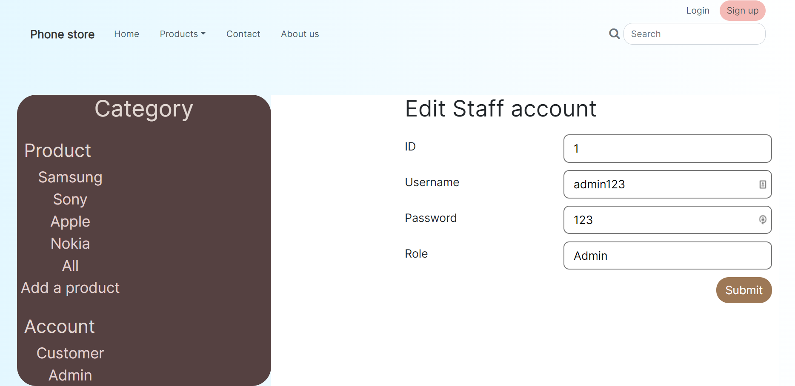

<div class="row">

<div class="col">

<h1 style="margin-bottom: 22px;">Edit Staff account</h1>

<form action= "editStaffAcc.php" method="post" enctype="multipart/form-data">

<div class="row" style="margin-bottom: 2%;">

<div class="col-xxl-5 d-xxl-flex align-items-xxl-center">

<div class="row">

<div class="col">

<h5>ID</h5>

</div>

</div>

</div>

<div class="col-xxl-7">

<div class="row">

<div class="col"><input class="form-control-lg" type="text" id="id" name="id" value="<?php echo $accountEdit[0][0]?>" placeholder="ID" style="border-radius: 10px;border-style: solid;width: 100%;" readonly></div>

</div>

</div>

</div>

<div class="row" style="margin-bottom: 2%;">

<div class="col-xxl-5 d-xxl-flex align-items-xxl-center">

<div class="row">

<div class="col">

<h5>Username</h5>

</div>

</div>

</div>

<div class="col-xxl-7">

<div class="row">

<div class="col"><input class="form-control-lg" type="text" id="username" name="username" value="<?php echo $accountEdit[0][1]?>" placeholder="Username" style="border-radius: 10px;border-style: solid;width: 100%;"></div>

</div>

</div>

</div>

<div class="row" style="margin-bottom: 2%;">

<div class="col-xxl-5 d-xxl-flex align-items-xxl-center">

<div class="row">

<div class="col">

<h5>Password</h5>

</div>

</div>

</div>

<div class="col-xxl-7">

<div class="row">

<div class="col"><input class="form-control-lg" id="password" type="text" name="password" value="<?php echo $accountEdit[0][2]?>" placeholder="Password" style="border-radius: 10px;border-style: solid;width: 100%;"></div>

</div>

</div>

</div>

<div class="row" style="margin-bottom: 2%;">

<div class="col-xxl-5 d-xxl-flex align-items-xxl-center">

<div class="row">

<div class="col">

<h5>Role</h5>

</div>

</div>

</div>

<div class="col-xxl-7">

<div class="row">

<div class="col"><input class="form-control-lg" type="text" name="role" value="<?php echo $accountEdit[0][3]?>" placeholder="Admin" style="border-radius: 10px;border-style: solid;width: 100%;"></div>

</div>

</div>

</div>

<div class="row d-xxl-flex justify-content-xxl-end">

<div class="col-auto d-xxl-flex justify-content-xxl-end">

<button name="submit" type="submit" class="btn btn-primary btn-lg" type="button" style="background: rgb(157,120,86);border-style: none;border-radius: 22px;">Submit

</button>

</div>

</div>

</form>

</div>

</div>

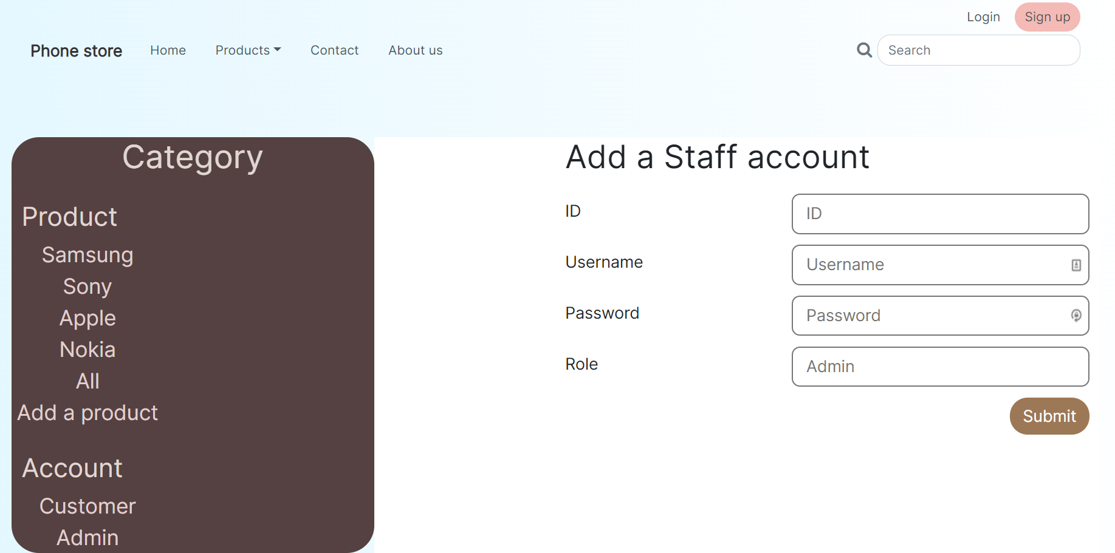

<div class="row">

<div class="col">

<h1 style="margin-bottom: 22px;">Add a Staff account</h1>

<form action= "admin-addAcc.php" method="post" enctype="multipart/form-data">

<div class="row" style="margin-bottom: 2%;">

<div class="col-xxl-5 d-xxl-flex align-items-xxl-center">

<div class="row">

<div class="col">

<h5>ID</h5>

</div>

</div>

</div>

<div class="col-xxl-7">

<div class="row">

<div class="col"><input class="form-control-lg" type="text" id="id" name="id" placeholder="ID" style="border-radius: 10px;border-style: solid;width: 100%;" readonly></div>

</div>

</div>

</div>

<div class="row" style="margin-bottom: 2%;">

<div class="col-xxl-5 d-xxl-flex align-items-xxl-center">

<div class="row">

<div class="col">

<h5>Username</h5>

</div>

</div>

</div>

<div class="col-xxl-7">

<div class="row">

<div class="col"><input class="form-control-lg" type="text" id="username" name="username" placeholder="Username" style="border-radius: 10px;border-style: solid;width: 100%;"></div>

</div>

</div>

</div>

<div class="row" style="margin-bottom: 2%;">

<div class="col-xxl-5 d-xxl-flex align-items-xxl-center">

<div class="row">

<div class="col">

<h5>Password</h5>

</div>

</div>

</div>

<div class="col-xxl-7">

<div class="row">

<div class="col"><input class="form-control-lg" id="password" type="text" name="password" placeholder="Password" style="border-radius: 10px;border-style: solid;width: 100%;"></div>

</div>

</div>

</div>

<div class="row" style="margin-bottom: 2%;">

<div class="col-xxl-5 d-xxl-flex align-items-xxl-center">

<div class="row">

<div class="col">

<h5>Role</h5>

</div>

</div>

</div>

<div class="col-xxl-7">

<div class="row">

<div class="col"><input class="form-control-lg" type="text" name="role" placeholder="Admin" style="border-radius: 10px;border-style: solid;width: 100%;"></div>

</div>

</div>

</div>

<div class="row d-xxl-flex justify-content-xxl-end">

<div class="col-auto d-xxl-flex justify-content-xxl-end">

<button name="submit" type="submit" class="btn btn-primary btn-lg" type="button" style="background: rgb(157,120,86);border-style: none;border-radius: 22px;">Submit

</button>

</div>

</div>

</form>

</div>

</div>

Similar to the relationship add/edit product, add/edit staff accounts are similar in terms of design and code with differences in their sql code.

### 1.9 Edit customer account

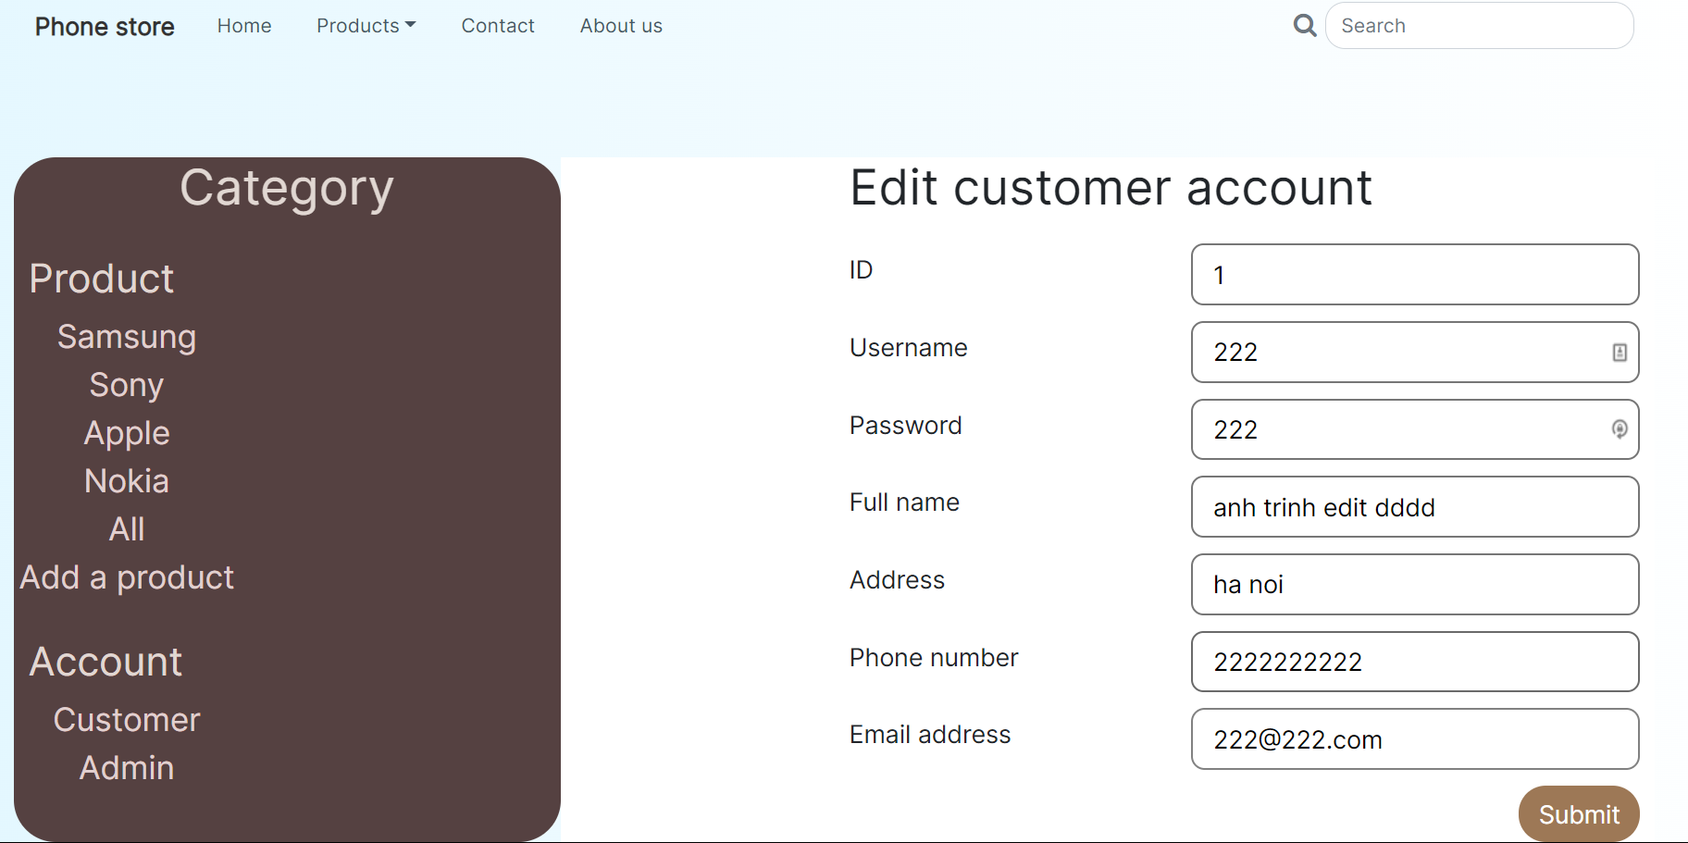

This page lets the user modify the information of a customer.

<div class="row">

<div class="col">

<h1 style="margin-bottom: 22px;">Edit customer account</h1>

<form action = "editcustomer.php" method="POST" enctype="multipart/form-data">

<div class="row" style="margin-bottom: 2%;">

<div class="col-xxl-5 d-xxl-flex align-items-xxl-center">

<div class="row">

<div class="col">

<h5>ID</h5>

</div>

</div>

</div>

<div class="col-xxl-7">

<div class="row">

<div class="col"><input class="form-control-lg" type="text" id="id" name="id" value="<?php echo $customerEdit[0][0]?>" placeholder="ID" style="border-radius: 10px;border-style: solid;width: 100%;" readonly></div>

</div>

</div>

</div>

<div class="row" style="margin-bottom: 2%;">

<div class="col-xxl-5 d-xxl-flex align-items-xxl-center">

<div class="row">

<div class="col">

<h5>Username</h5>

</div>

</div>

</div>

<div class="col-xxl-7">

<div class="row">

<div class="col"><input class="form-control-lg" value = "<?php echo $customerEdit[0][5]?>" type="text" name="username" placeholder="Username" style="border-radius: 10px;border-style: solid;width: 100%;"></div>

</div>

</div>

</div>

<div class="row" style="margin-bottom: 2%;">

<div class="col-xxl-5 d-xxl-flex align-items-xxl-center">

<div class="row">

<div class="col">

<h5>Password</h5>

</div>

</div>

</div>

<div class="col-xxl-7">

<div class="row">

<div class="col"><input class="form-control-lg" type="text" name="password" placeholder="Password" value = "<?php echo $customerEdit[0][6]?>" style="border-radius: 10px;border-style: solid;width: 100%;"></div>

</div>

</div>

</div>

<div class="row" style="margin-bottom: 2%;">

<div class="col-xxl-5 d-xxl-flex align-items-xxl-center">

<div class="row">

<div class="col">

<h5>Full name</h5>

</div>

</div>

</div>

<div class="col-xxl-7">

<div class="row">

<div class="col"><input class="form-control-lg" type="text" name="fullName" placeholder="Alice Bob" value = "<?php echo $customerEdit[0][1]?>" style="border-radius: 10px;border-style: solid;width: 100%;"></div>

</div>

</div>

</div>

<div class="row" style="margin-bottom: 2%;">

<div class="col-xxl-5 d-xxl-flex align-items-xxl-center">

<div class="row">

<div class="col">

<h5>Address</h5>

</div>

</div>

</div>

<div class="col-xxl-7">

<div class="row">

<div class="col"><input class="form-control-lg" type="text" name="address" placeholder="123 George Ave, Sunken City, Banana" value = "<?php echo $customerEdit[0][2]?>" style="border-radius: 10px;border-style: solid;width: 100%;"></div>

</div>

</div>

</div>

<div class="row" style="margin-bottom: 2%;">

<div class="col-xxl-5 d-xxl-flex align-items-xxl-center">

<div class="row">

<div class="col">

<h5>Phone number</h5>

</div>

</div>

</div>

<div class="col-xxl-7">

<div class="row">

<div class="col"><input class="form-control-lg" type="tel" name="phone" placeholder="123 456 7890" value = "<?php echo $customerEdit[0][3]?>" style="border-radius: 10px;border: 2px solid rgb(106,106,106);width: 100%;"></div>

</div>

</div>

</div>

<div class="row" style="margin-bottom: 2%;">

<div class="col-xxl-5 d-xxl-flex align-items-xxl-center">

<div class="row">

<div class="col">

<h5>Email address</h5>

</div>

</div>

</div>

<div class="col-xxl-7">

<div class="row">

<div class="col"><input class="form-control-lg" type="email" placeholder="abc@example.com" name="email" value = "<?php echo $customerEdit[0][4]?>" style="border-radius: 11px;border-style: solid;border-color: rgb(129,129,129);width: 100%;"></div>

</div>

</div>

</div>

<div class="row d-xxl-flex justify-content-xxl-end">

<div class="col-auto d-xxl-flex justify-content-xxl-end">

<button class="btn btn-primary btn-lg" type="submit" name = "submit" style="background: rgb(157,120,86);border-style: none;border-radius: 22px;">Submit</button>

</div>

</div>

</form>

</div>

</div>

## 2. Comparison of custom-built multi-page website and design document

Originally, the wireframe of the website was designed to have a promotion banner that carousels between different promos to greet the customers with good deals that are happening. After presenting it to the client, they have requested that it be removed as they do not plan on any promotional program and that space would be unnecessary for the website. Therefore, the section has been removed from the final product.

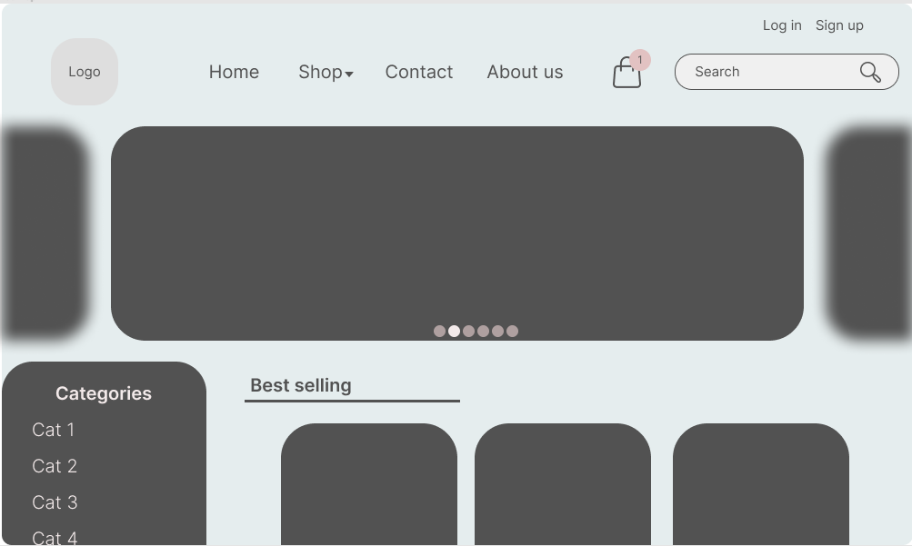

Figure Original wireframe of the website

Additionally, the product cards’ background has been changed from dark gray to a white color as most products has white background for their image, putting them inside a dark container would make the website feel cheap and be considered a design flaw. A footer for the website was also added to display additional information for the visitor.



Figure Wireframe of the final design

The changes made to the display of the product have made the website fit more well with the client’s requirements and improved the user experience in terms of design structure. It also provides a new section for additional information where it is conventionally placed, helping the user navigate the website with ease.

# III. Test plan

## 1. Introduction

This test plan aims to show that the website work as designed and developed. Numerous functions will be tested to ensure that the website work as intended

## 2. Test case

|  |  |  |  |  |  |
| --- | --- | --- | --- | --- | --- |
| No | What is being tested | Methodology | Data used | Expected result | Actual result |
| 1 | Only products of a certain brand is displayed when a brand is clicked on | Click on a brand name on the sidebar menu | Samsung | Samsung products displays | Good |
| 2 | Only products whose names contain the keyword in the search bar is displayed | Enter a keyword and press enter | "13 pro max" | Iphone 13 promax is displayed | Good |
| 3 | Submitting a contact form | Enter full name, email address, and contact message into the form and submit | Name: "Bob Jackson" Email address: "b.jackson@gmail.com" Message: "I need help with device purchased from your store | The form submits successfully and appear on the database | Good |
| 4 | Sign up for a new customer account using valid data | Enter information into the field on the sign up page and click "Sign up" button | Random data into the fields with username and email unique from what are on the database | The account is successfully created and the account appear on the database | good |
|  | Sign up for a new customer account using invalid data | Enter information into the field on the sign up page and click "Sign up" button | Random data into the fields with a username that already exists on the database | Error message saying username already exist and account not created | Good |
|  | Sign up for a new customer account using invalid data | Enter information into the field on the sign up page and click "Sign up" button | Random data into the fields with a email address that already exists on the database | Error message saying email address already exist and account not created | Good |
|  | Sign up for a new customer account using invalid data | Enter information into the field on the sign up page and click "Sign up" button | Random data into the fields with a email address and username that already exist on the database | Error message saying username and email address already exist and account not created | Good |
| 5 | Sign into the admin page using valid data | Enter information into the field on the log in page and click "Log in" button | Account data that exists on the database | The user is redirected to the admin page | Good |
|  | Sign into the admin page using invalid data | Enter information into the field on the log in page and click "Log in" button | Account data that does not exist on the database | Error message saying invalid credential and returns to the log in page | Good |
| 6 | Delete a product | Click on the "Delete" button on a product in the admin page | Delete | The product is removed from the database | Good |
| 7 | Modify a product's information | Click on the "Edit" button on a product in the admin page, enter new information and click "Submit" | In every field except for the "Product ID", add the word "edited" and change the image | All information about the product except for the Product ID is added with "edited", new picture for the product appear | Good |
| 8 | Add a new product | Click on the "Add a product" link on the admin page's sidebar | Random information in each field with the correct data type | A product with entered information is added into the database | Good |
| 9 | Delete a customer account | Click on the "Delete" button on a customer account in the admin page | Delete | The account is removed from the database | Good |
| 10 | Delete a staff account | Click on the "Delete" button on a staff account in the admin page | Delete | The account is removed from the database | Good |
| 11 | Add a staff account | Click on the "Add an account" button on the staff accounts page, enter information on each field except for the ID | Random information in each field with the correct data type | A new account with entered information is added into the database | Good |
| 12 | Modify a customer information | Click on the "Edit" button on an account in the customer accounts page, enter new information and click "Submit" | In every field except for the "ID", add the word "edited" | All information about the customer except for the ID is added with "edited" | Good |
| 13 | Modify a staff account | Click on the "Edit" button on an account in the staff accounts page, enter new information and click "Submit" | In every field except for the "ID", add the word "edited" | All information about the customer except for the ID is added with "edited" | Good |

## 3. Screenshot

### 3.1 Display products by brand and keyword

This is the product list by default. It is apparent that all products are displayed

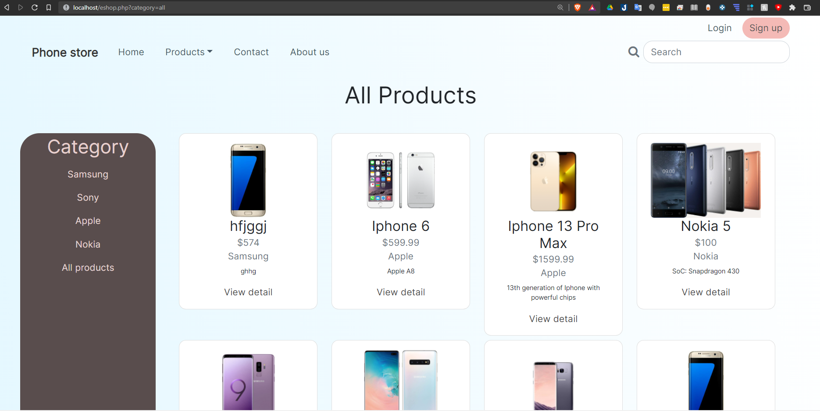

When the brand “Samsung” is clicked on, only Samsung products are displayed

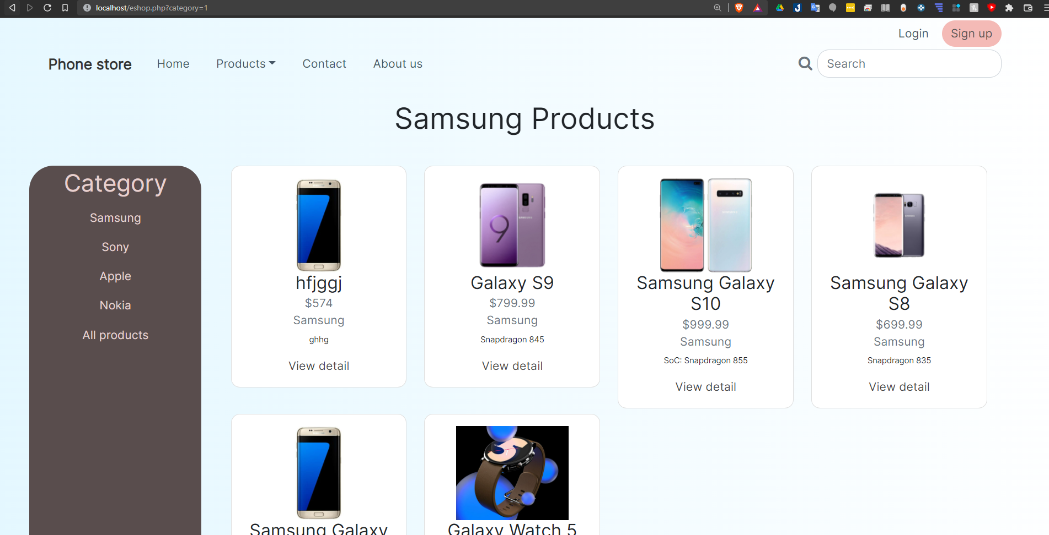

When the keyword “galaxy” is input and enter button is clicked, only products that contain the keyword “galaxy” display

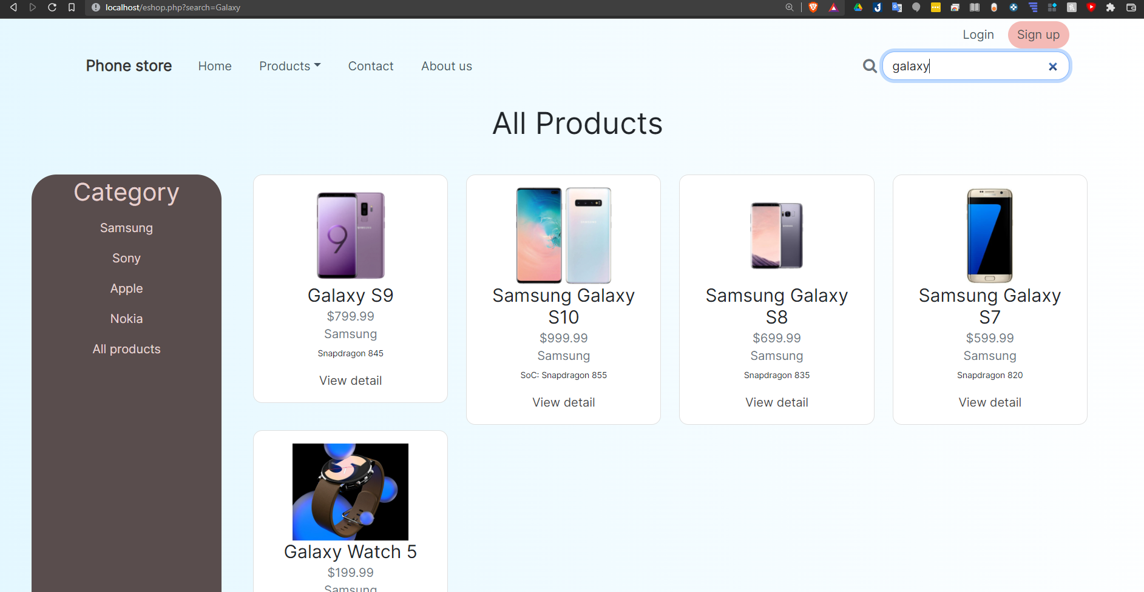

### 3.2 Contact form

The information will be input into the form and the “Send” button is clicked

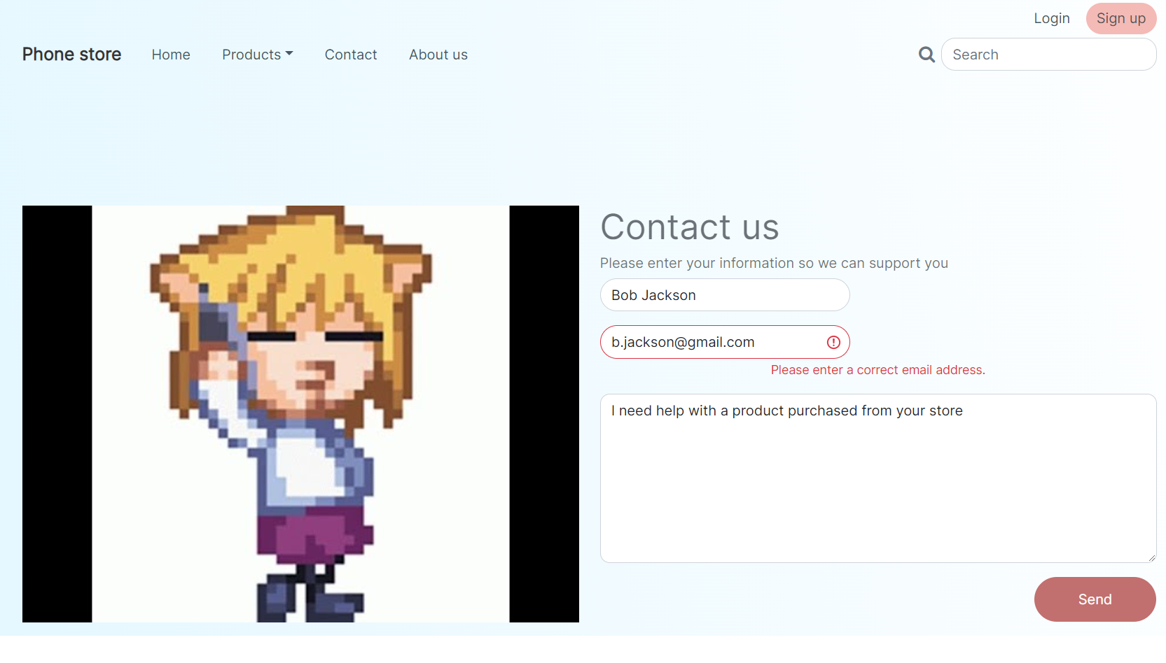

An alert window saying the message is sent successfully is displayed

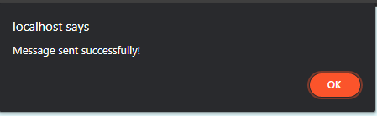

The message along with the information appears in the database

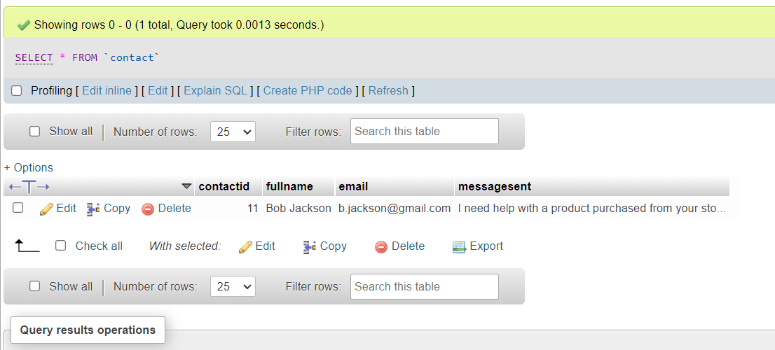

### 3.3 Sign up

In the database, currently, there is one customer account

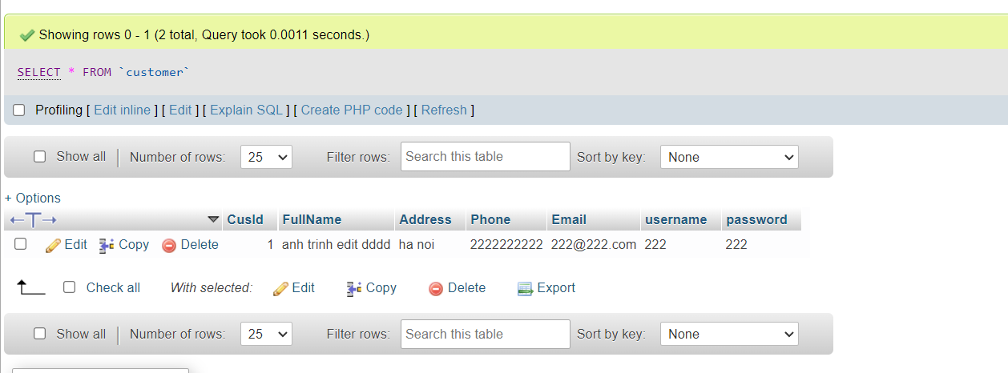

Now the data will be input into the field with unique username and email address

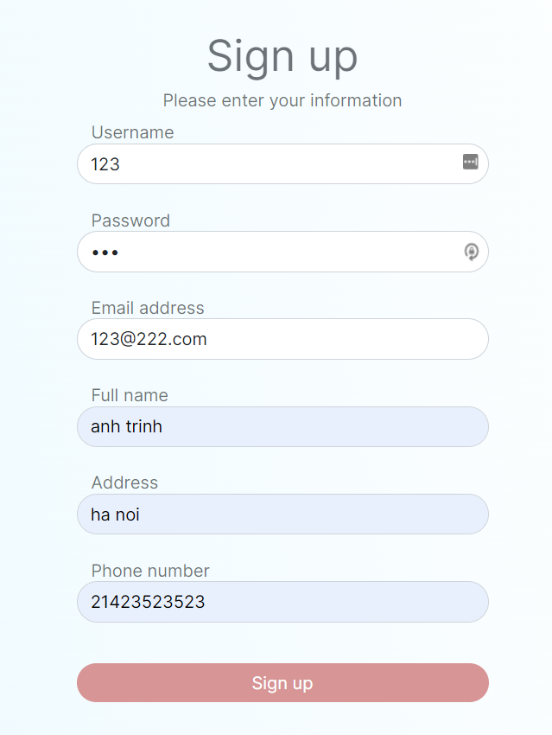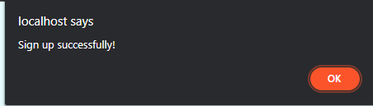

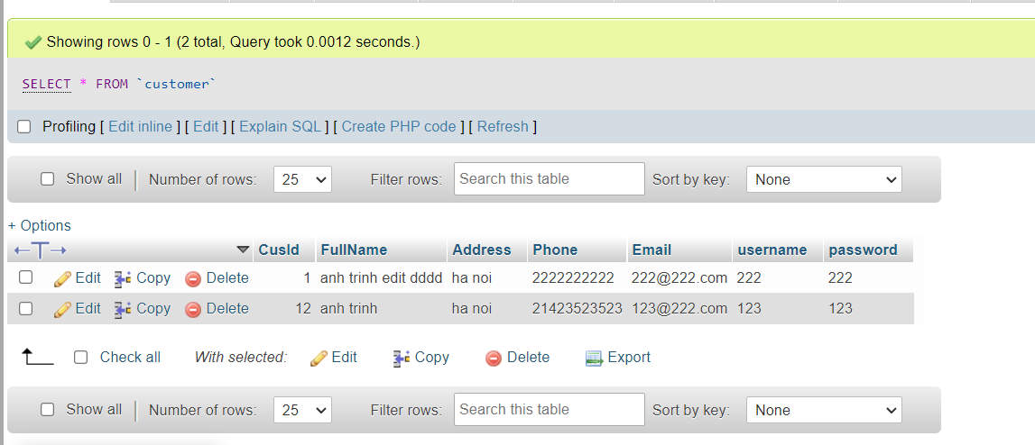

Now information with duplicated username, email address, and both will be entered

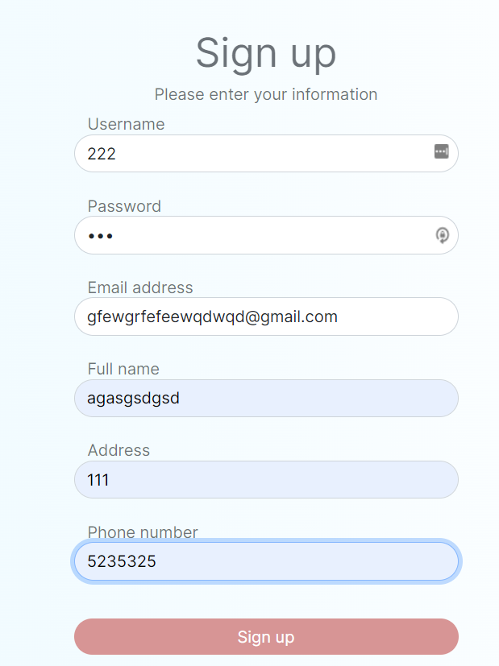

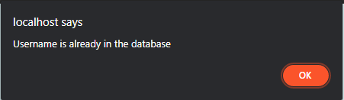

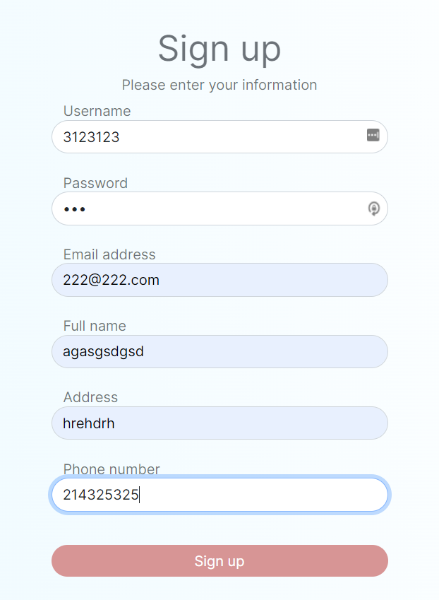

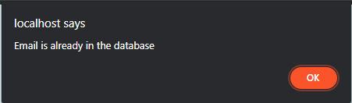

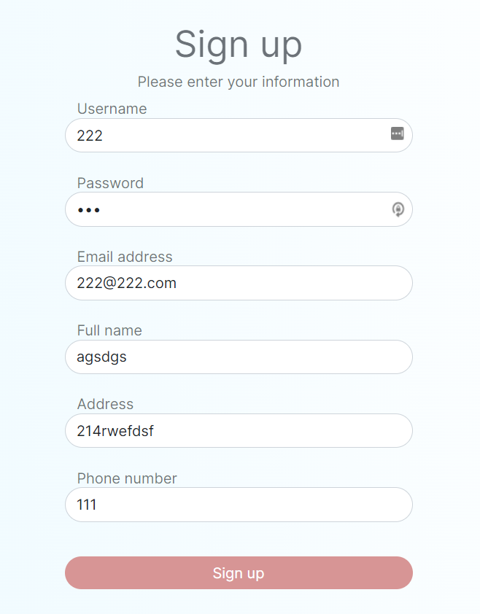

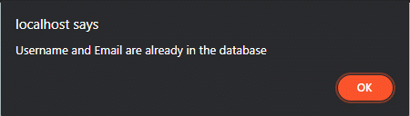

After all the attempts, only one account with valid data is created in the database

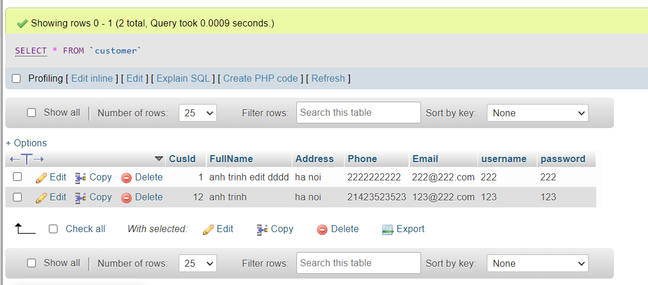

### 3.4 Log in

In this page, wrong credentials will be input first to show how the system responds to them first before moving on the correct ones

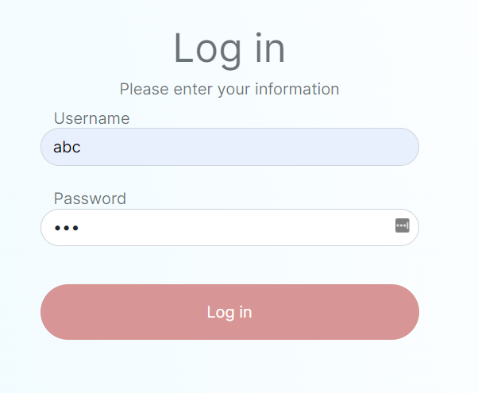

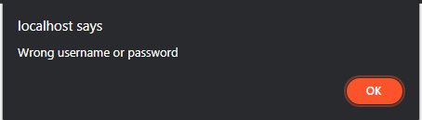

Then, the right credentials are input

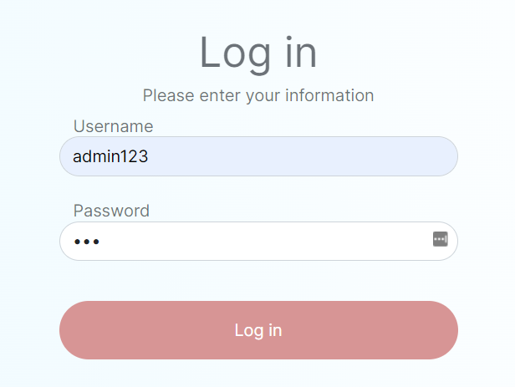3.5 Admin page

After the user entered the credentials of an admin account, they will be transferred to the admin page

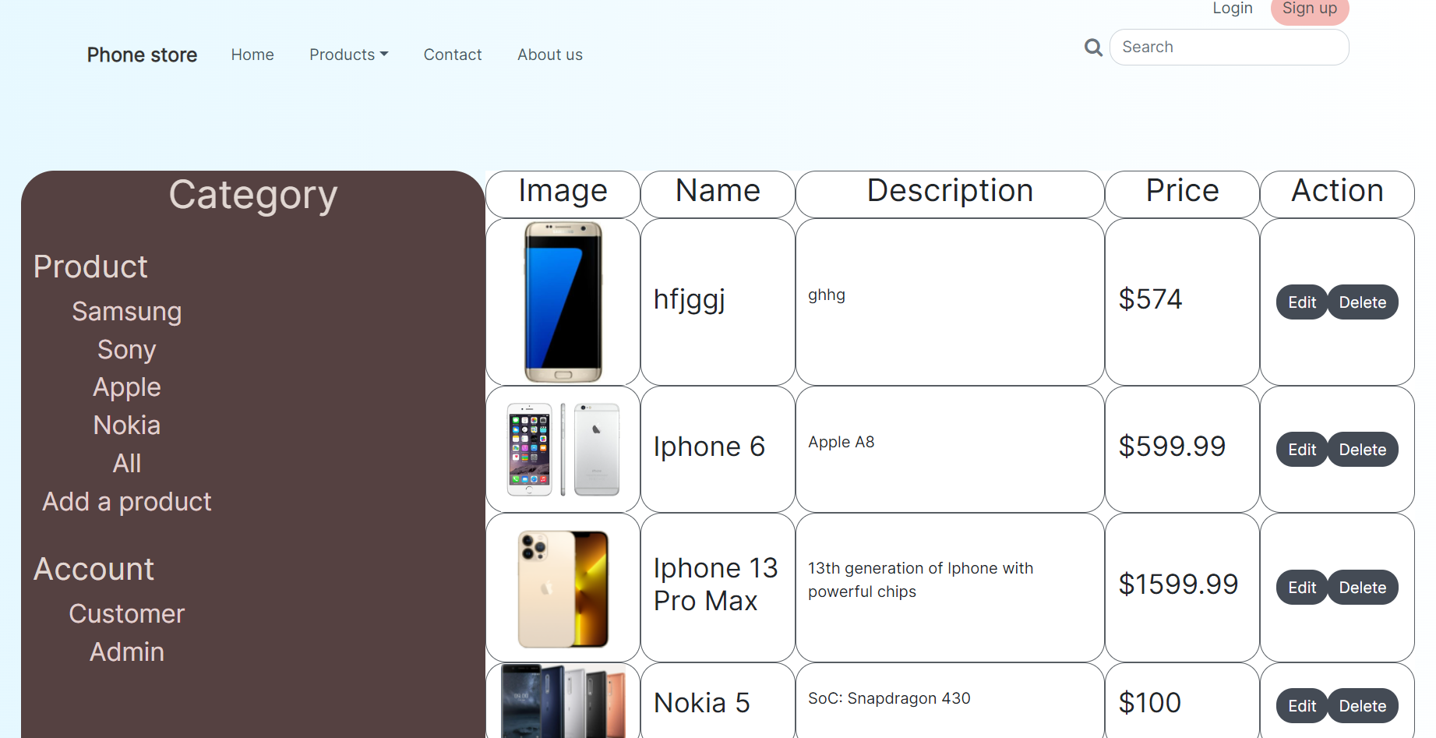

### 3.6 Delete product

The product with the name “hfjggj” will be deleted by clicking the “Delete” button

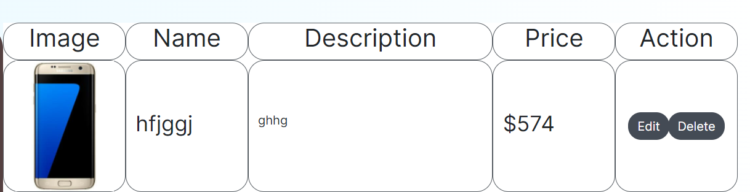

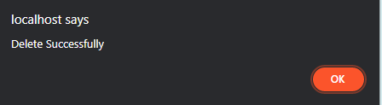

Now the product is gone from the list

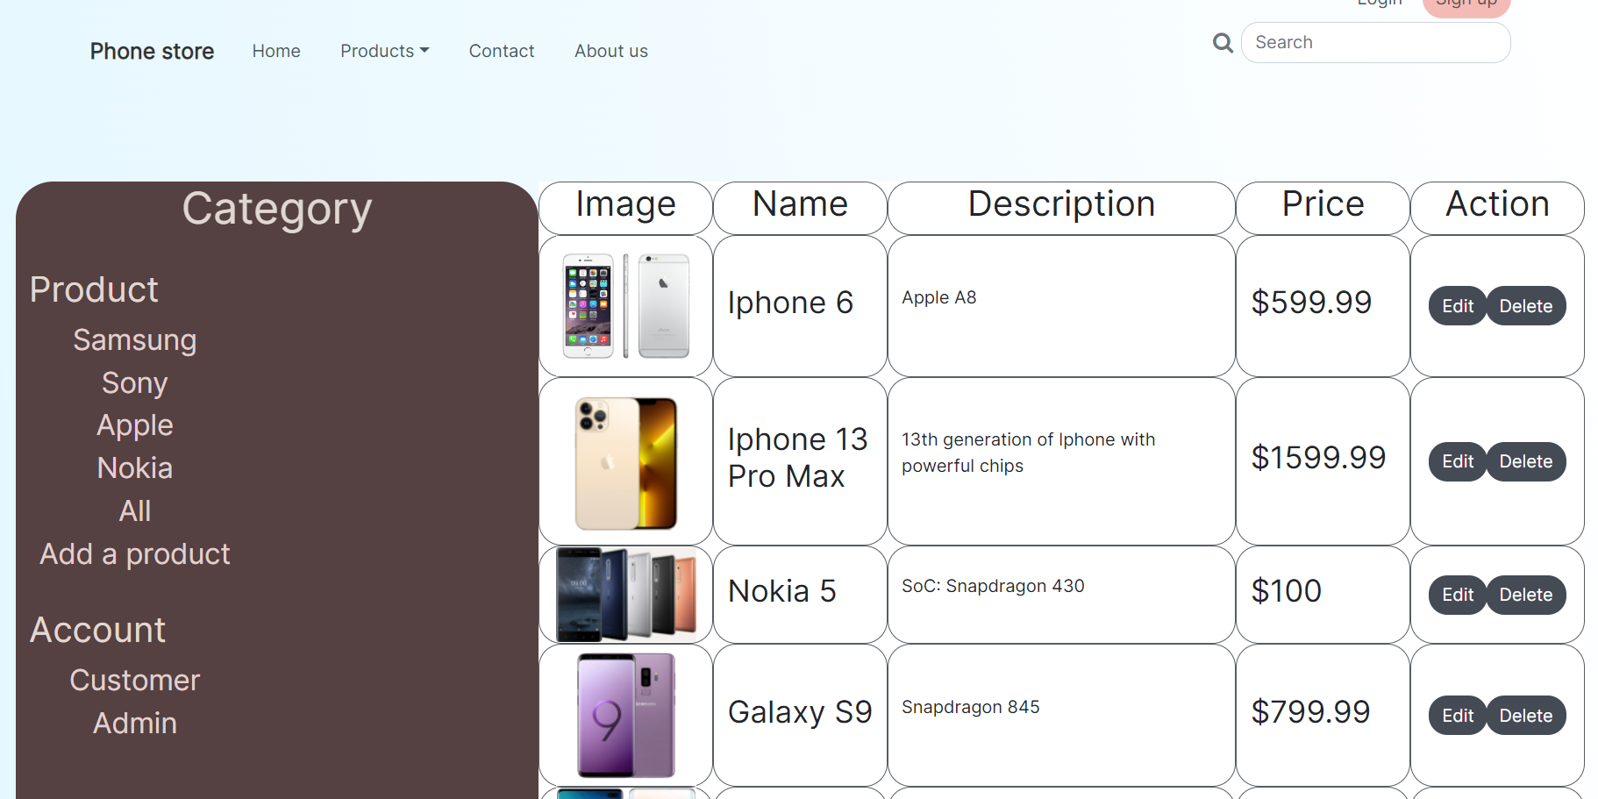

### 3.7 Edit product

By clicking the edit button on a product, the user will be transferred to a page that lets them edit its details

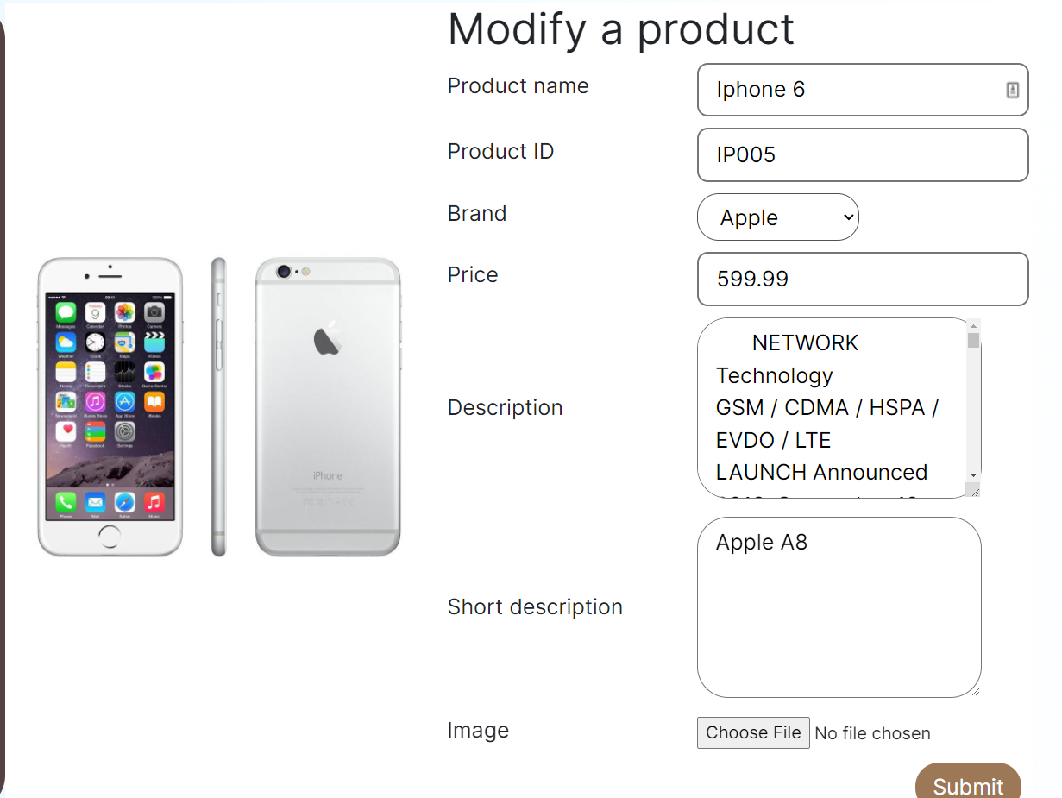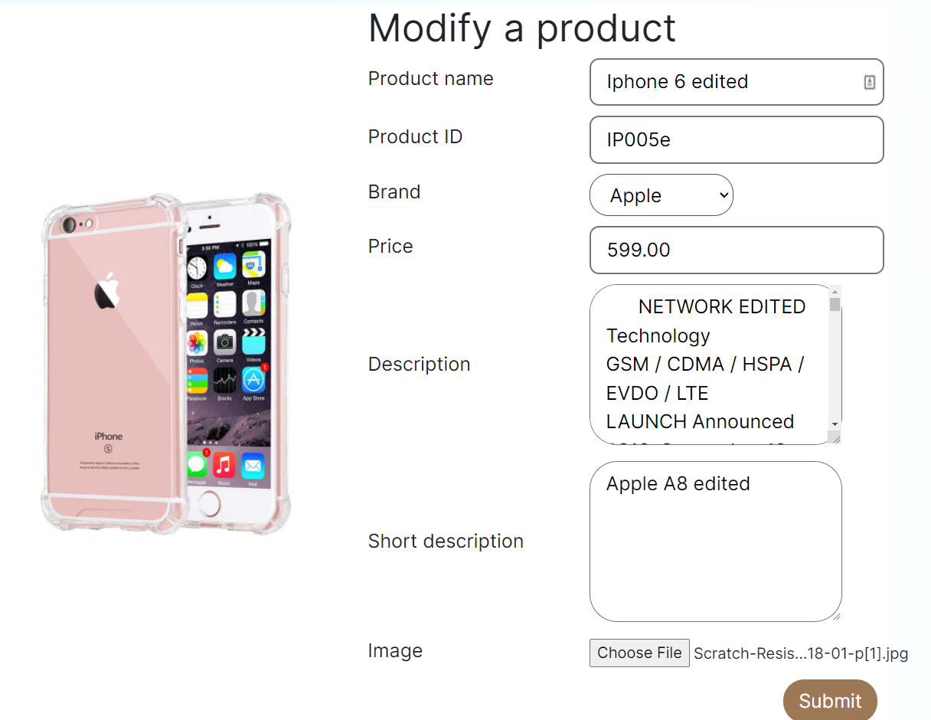

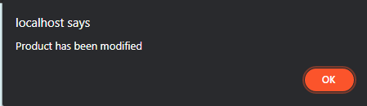

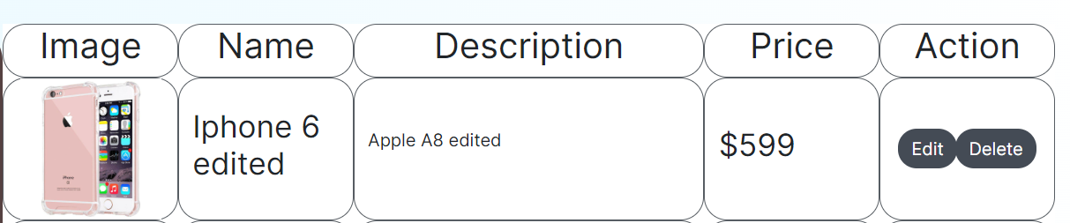

The product’s information has been changed

### 3.8 Add product

When the user clicks the “add a product” link on the sidebar, they will be redirected to a page that lets them add a product onto the system

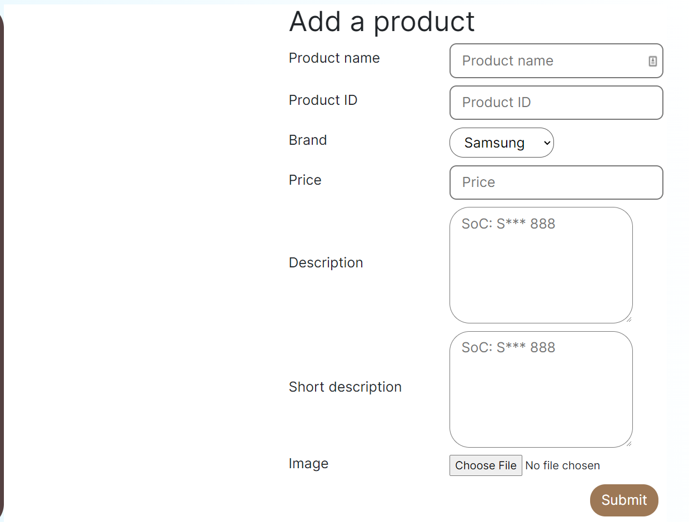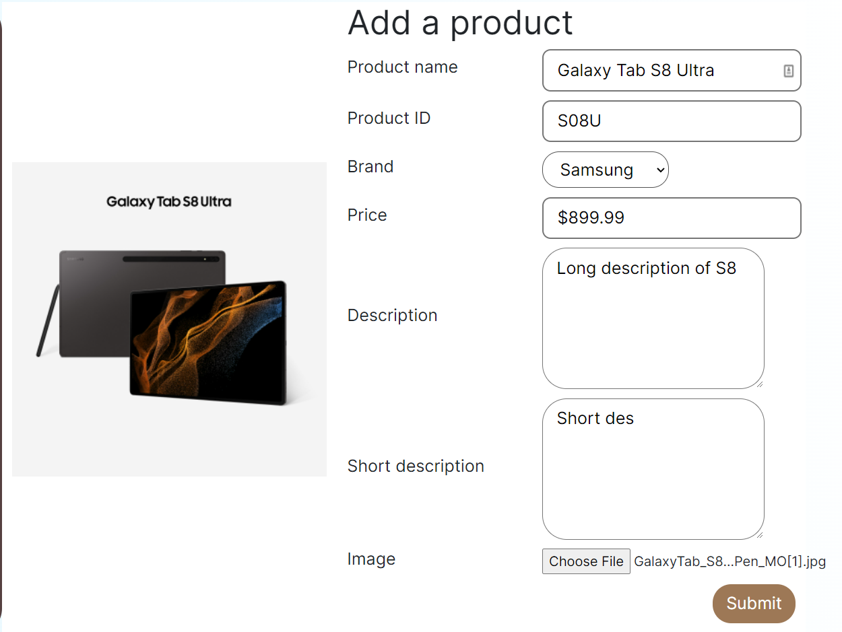

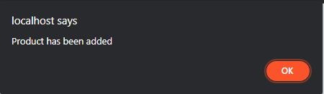

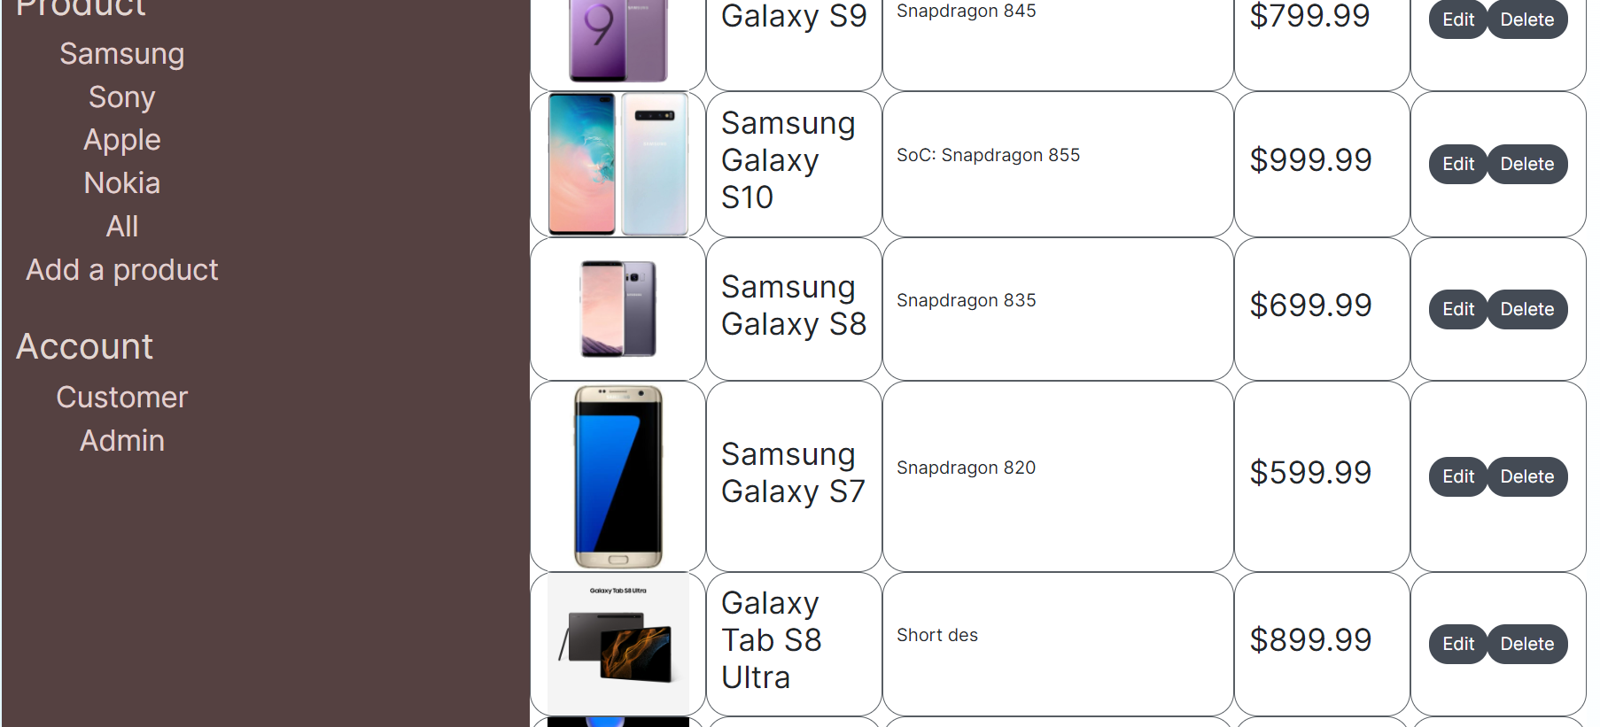

### 3.9 Account management

From the admin page, the user can manage accounts on the system by clicking on either Customer or Admin link under the Account section, each will lead the user to a list of different accounts

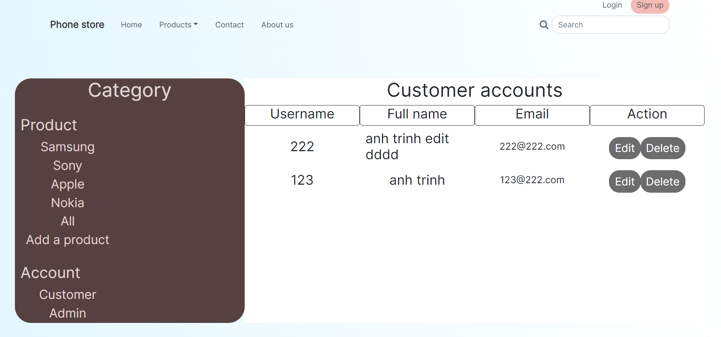

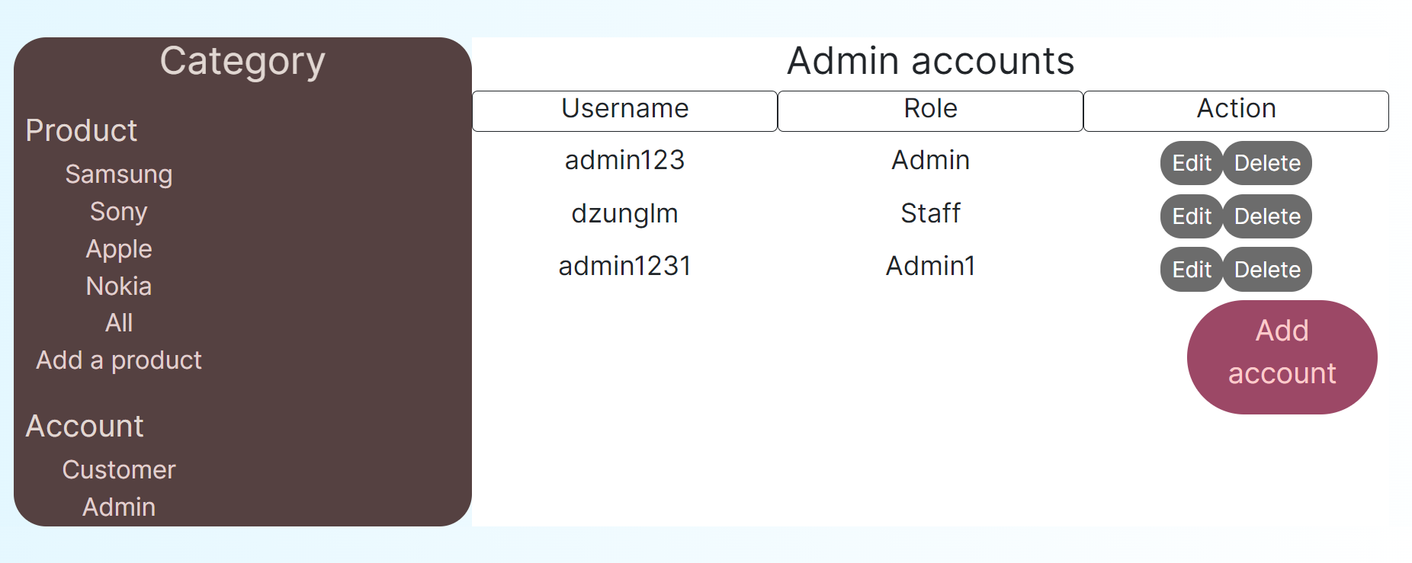

### 3.10 Edit account

On the account management, click on the “Edit” button

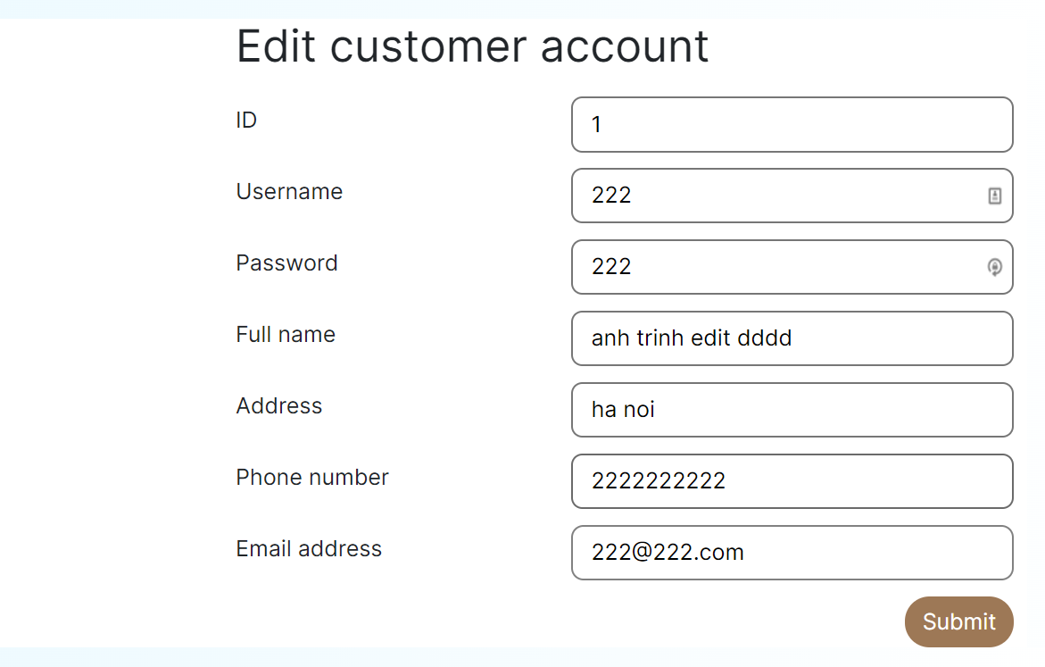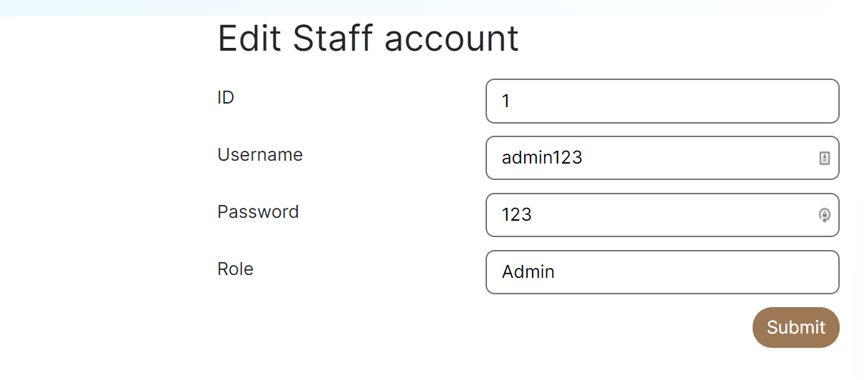

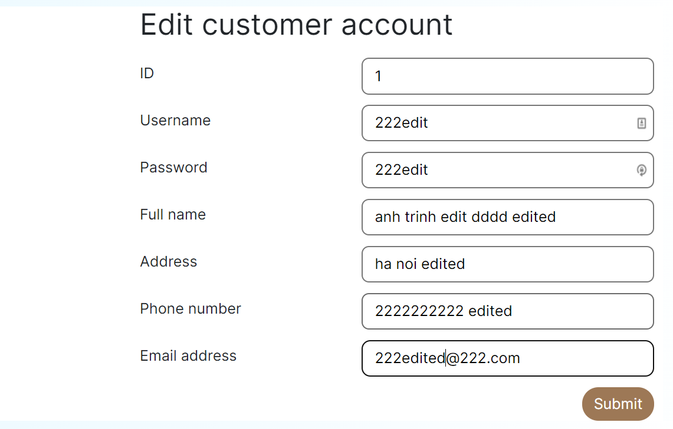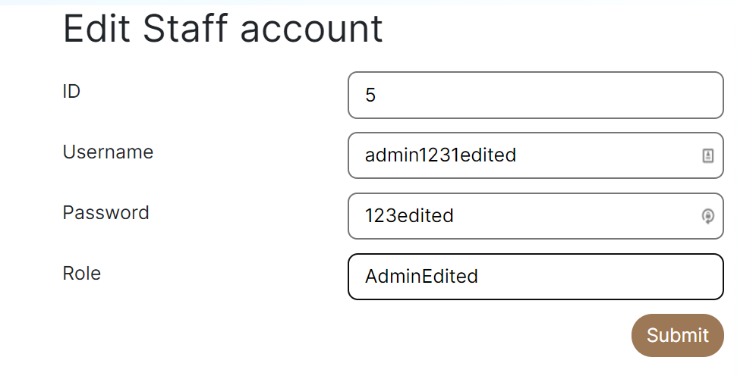

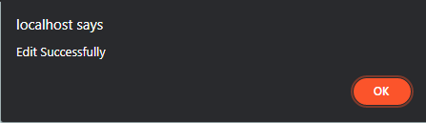

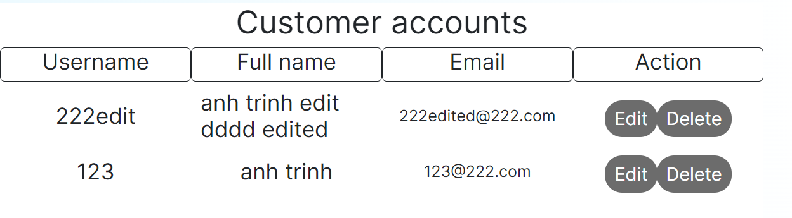

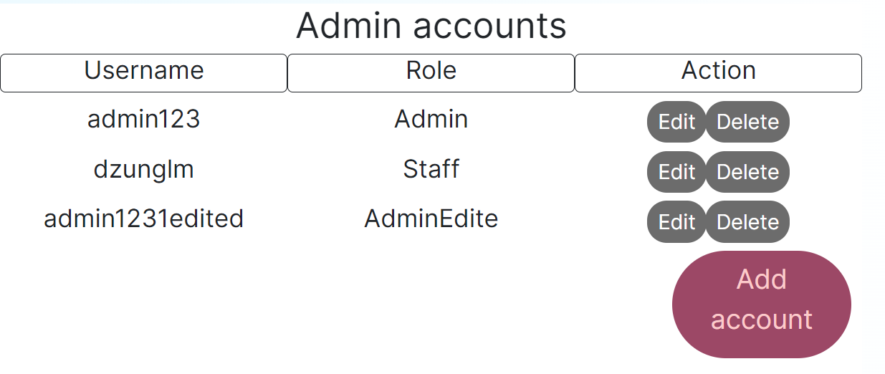

### 3.11 Delete account

The Delete button on the account “admin1231edited” and “222edit” will be clicked

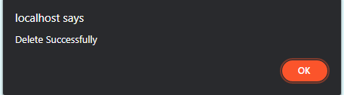

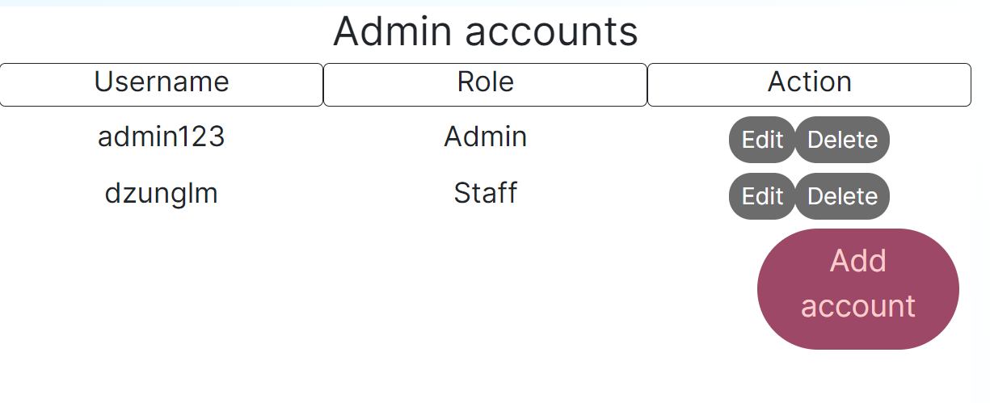

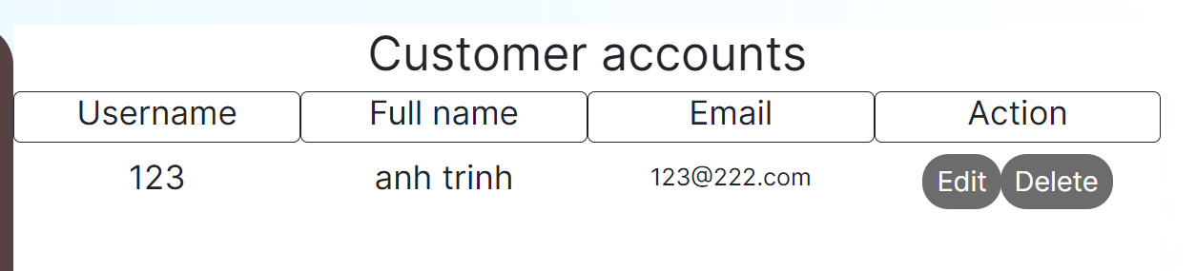

# IV. Quality assurance (QA) process and how it was implemented in the project

Quality assurance (QA) is a systemized process to ensure that a product or a service meet specific expectations. (Gillis, 2019)

QA creates and maintains standards for creating or producing dependable goods. A quality assurance system is intended to boost consumer confidence and a firm's legitimacy while also enhancing work procedures and efficiency, allowing a company to compete more effectively. (Gillis, 2019)

## Steps to implement QA

### 1. Functionality testing

Functionality testing is a process that makes sure that the software components work up to expectations. Functions are input with mock data and the output will be evaluated to see if it passes the testing.

A typical functional testing includes:

* Addressing the expectations on the functions tested.
* Data to be input.
* Test case execution.
* Analysis of the result.

### 2. Usability testing

A combination of functionality testing and overall user experience to ensure that an average internet user can make use of the website.

Usability testing involves:

* Developing a test plan that put every function under test and evaluation, including navigation and content.
* Inviting test participants, from inside and outside of the team.
* Running the test under professional observation.
* Analyzing the results to improve the application accordingly.

### 3. Interface testing

Interface testing is implemented to ensure that all interactions between the web server and application interfaces run smoothly. This is done by checking the processes of communication and ensure that error messages are displayed correctly and ensure that both sides handle any interruptions correctly

### 4. Compatibility testing

This step ensures that the application/website is compatible on as many devices and software as possible. It can be the compatibility between the application and browser, operating systems, or mobile devices.

### 5. Performance testing

After ensuring that the application/website functions properly and responsively on every platform specified. It is time that it got tested under load. This is done by sending the application various rate of request to see how the system handle the normal and peak loads (load testing). It is also put under increasing load until the it stops working to determine the system’s breakpoint (stress testing).

### 6. Security testing

Security testing ensures that the data is stored safely on the system and transferred safely between the server and clients in order to protect their information, increasing the credibility of the company. It includes:

* Secure transmission
* Authentication
* Session Management
* Authorization
* Cryptography
* Data Validation
* Denial of Service
* Specific Functionality Tests
* Error Handling

## How the QA is applied to this project

In this project, these steps have been applied in testing the system

* Functionality testing to make sure that every function programmed work as intended
* Interface testing to make sure that the user can use the website with ease
* Compatibility to make sure that it can run properly on multiple platforms

# References

Centre For Accessibility Australia, 2022. *What is WCAG?.* [Online]   
Available at: https://www.accessibility.org.au/guides/what-is-the-wcag-standard/  
[Accessed 01 May 2022].

Gillis, A. S., 2019. *quality assurance (QA).* [Online]   
Available at: https://www.techtarget.com/searchsoftwarequality/definition/quality-assurance?vgnextfmt=print  
[Accessed 03 May 2022].